Contents



KUSHINGA PHIKELELA P

OLYTECHNIC



[

**DIGITAL SOCCER SYSTEM**

]

**NAME**

**:**

**MUSODZA GABRIEL TENDAI**

**CANDIDATE**

**No**

**:**

**1116004G00007**

**PROGRAM**

**:**

**INFORMATIO**

**N TECHNOLOGY**

**SUBJECT CODE**

**:**

**553/15**

**/S**

**08**

**SUBJECT**

**:**

**SOFTWARE**

**PROJECT**

**SUPERVISOR**

**:**

**MR CHIGU**

**ACADEMIC**

**YEAR 2017**

This Project is submitted in partial fulfilment of the requirements of National

Diploma

in Information Technol

ogy

.

# ABSTRACT

The purpose of the study was to identify the problems that the system atmy Collehge. The study sought to unearth the capabilities of the current system at the Football Association and its limitations as well. To carry out the study the researcher used a variety of data collection techniques such as observations, questionnaires, and interviews. In the case, questionnaires were given to a certain number of citizens and interviews were also conducted. All the questionnaires distributed were returned to the researcher. Information specific to the Division One league and its current system was gathered from the system users during the analysis phase. Different user expectations were presented to the researcher and in some cases conflicting user requirements were given. The results included the problem of complexity in retrieval and synchronisation of records and difficulties in producing summary reports as records are scattered all over and data collected manually. Basing on the findings from the study, the researcher devised an in-house developed Digital Soccer System that attempts to satisfy the organization and the citizens in fairness in the Sport, amendment, and interpretation. The main aim of the Digital Soccer System is to provide an online team and player registration, to develop scheduling of matches and to record match statics implement a web system.

# Acknowledgements

First of all, I am so happy to thank God for his day to day care of my life and without him all my efforts would be useless. I would also like to express my gratitude to my supervisor Mr Chigu for his guidance, support and his continuous supervision throughout the project. I am also very grateful to extend my sincere thanks to my college for their cooperation in providing all the necessary information throughout my study. My class mates also deserve special thanks for being helping and giving me suggestions and corrections throughout the project.

Most importantly, I would like to thank my beloved family for their support and encouragement which goes even beyond the accomplishment of this project.

KUSHINGA PHIKELELA POLYTECHNIC .................................................................................... 1

.................................................................................................................................................... 1

[**KAMBUDZI LEARNI SYSTEM**] ........................................................................................................... 1

Chapter 1 ..................................................................................................................................... 1

**1.0** **INTRODUCTION**........................................................................................................ 1

**1.1** **BACKGROUND STUDY**............................................................................................. 1

**1.2** **PROBLEM STATEMENT** .......................................................................................... 3

**1.3 OBJECTIVES** ................................................................................................................... 4

**1.4 HYPOTHESIS**................................................................................................................... 4

**1.5 Justification** ....................................................................................................................... 4

**1.6 Assumptions** ...................................................................................................................... 4

**1.7 Delimitation of the study**.................................................................................................... 5

**1.8 Limitations of the study** ..................................................................................................... 5

**1.9 Definition of terms** ............................................................................................................. 5

1.10 Report outline ................................................................................................................... 6

**Introduction** This is the opening chapter of the research project. It covers the introduction, background of the study, problem definition, objectives of the project, hypothesis justification, Assumptions, Delimitation of the study, Limitations of the study and Definition of terms .............. 6

**1.11 Conclusion** ....................................................................................................................... 7

Chapter II..................................................................................................................................... 8

**2.0 Literature Review** .............................................................................................................. 8

**2.1 Introduction** ...................................................................................................................... 8

1. **2 Theoretical literature review** ............................................................................................ 9

2.2.0 Football League Scheduling in Europe ........................................................................... 9

2.2.1 English Premier League................................................................................................. 9

2.2.3 Danish League ............................................................................................................ 10

2.2.4 Fixture computer ......................................................................................................... 10

* 1. Football League Scheduling in South America .................................................................... 11

2.3.1 Brazilian League ......................................................................................................... 11

* 1. South African League .................................................................................................... 11
     1. Team and Player registration ........................................................................................... 12
     2. Whole Game System ................................................................................................... 12
     3. WASA Team and Player Electronic Registration Procedures ......................................... 13
     4. **in Australia** ............................................................................................................... 13

**2.6 Summary** ......................................................................................................................... 14

Justification- gap..................................................................................................................... 14

Significance- benefits .............................................................................................................. 15

CHAPTER 3 .............................................................................................................................. 16

Feasibility study ......................................................................................................................... 16

* 1. Feasibility study ................................................................................................................ 16
  2. Technical Feasibility.......................................................................................................... 16

HARDWARE AND SOFTWARE REQUIREMENTS .......................................................... 16

Minimum Software Requirements ........................................................................................ 16

* 1. Economical feasibility ....................................................................................................... 17

TANGIBLE BENEFITS ...................................................................................................... 17

INTANGIBLE BENEFITS .................................................................................................. 17

Tangible cost....................................................................................................................... 17

Intangible cost..................................................................................................................... 18

Cost benefits ....................................................................................................................... 18

Return on investment ........................................................................................................... 19

Net Present Value (NPV) Analysis ....................................................................................... 19

* 1. OPERATIONAL FEASIBILTY ......................................................................................... 20
  2. Project plan. ...................................................................................................................... 20

Gantt Chart............................................................................................................................. 21

Task description .................................................................................................................. 21 CHAPTER FOUR ...................................................................................................................... 22 REQUIREMENTS ANALYSIS .................................................................................................. 22

* 1. Introduction ...................................................................................................................... 22
  2. Requirements Analysis ...................................................................................................... 22

4.1 Functional Requirements ................................................................................................... 22

4.1 Non Functional Requirements ............................................................................................ 23

* + 1. User Interface................................................................................................................. 23
    2. Quality Issue .................................................................................................................. 23
    3. Security Issue ................................................................................................................. 23
    4. Error Handling ............................................................................................................... 23
    5. Alternatives. ................................................................................................................... 23
    6. Up grading the current manual system.............................................................................. 23
    7. Software Packages. ......................................................................................................... 24
    8. Outsourcing.................................................................................................................... 24
    9. In house development. .................................................................................................... 24
    10. System development choice............................................................................................. 25
    11. Proposed system. ............................................................................................................ 25
    12. Information gathering techniques. .................................................................................... 26
    13. Participatory................................................................................................................... 26
    14. Observation and Document Review ................................................................................. 26
    15. Interviews ...................................................................................................................... 27
    16. Questionnaire ................................................................................................................. 27

3.4.0 Weaknesses of the current system. ................................................................................... 28

4.5.0 Conclusion. .................................................................................................................... 29

CHAPTER FIVE ........................................................................................................................ 30

Design ....................................................................................................................................... 30 5. Introduction ........................................................................................................................ 30

Architectural design ................................................................................................................ 30

* + 1. Client Machines: ......................................................................................................... 30
    2. Server:........................................................................................................................ 30
    3. Network Topology....................................................................................................... 30
    4. Network Architecture .................................................................................................. 30
    5. Class Diagram of the System............................................................................................ 31
    6. Object diagram............................................................................................................... 32 Subsystem Decomposition ................................................................................................... 34

5.3 Database Design ............................................................................................................ 35

Table Users table .................................................................................................................... 35

**Table players Table**............................................................................................................... 35 Integrity Constraints ............................................................................................................ 41

* 1. Normalisation ............................................................................................................... 41
  2. Administration and Form Design ................................................................................... 42

Interface Design .................................................................................................................. 42

**Chapter Six** ............................................................................................................................... 47

**Coding and Testing** ................................................................................................................... 47

* 1. ***Introduction*** ..................................................................................................................... 47
  2. Coding .......................................................................................................................... 47
     1. Programming language ................................................................................................ 51
     2. Programming style ...................................................................................................... 51

6.1.2.1. The Top-Down Approach ........................................................................................ 51

Advantages of the Top-down approach ................................................................................. 51

Disadvantages ..................................................................................................................... 51

6.1.2 .1 The Top-Down Design of the proposed system.......................................................... 51

Advantages of modular programming ................................................................................... 52

***6.2 Testing*** ............................................................................................................................. 52

* + 1. Unit testing ................................................................................................................. 52
    2. Module testing ............................................................................................................ 53
    3. Interface testing .......................................................................................................... 53
    4. System testing............................................................................................................. 53 Testing phases outline.......................................................................................................... 53
    5. Acceptance testing ...................................................................................................... 53

Sample tests results ............................................................................................................. 54

Test 1 ................................................................................................................................. 54

Test 2: Can one access anything?.......................................................................................... 54

***6.3 Verification and Validation*** ............................................................................................... 54

* + 1. Validation................................................................................................................... 54
    2. Verification ................................................................................................................ 54

Chapter 7 ................................................................................................................................... 58

7.0 System Installation ............................................................................................................ 58

7.0.1 To install and host the system for final use. ...................................................................... 58

7.1 Methods of conversion....................................................................................................... 60

* + 1. Pilot conversion.............................................................................................................. 60
    2. Direct conversion ........................................................................................................... 60
    3. Parallel conversion ......................................................................................................... 60
    4. Decision......................................................................................................................... 60
  1. Training ...................................................................................................................... 60
  2. Maintenance ..................................................................................................................... 61

7.3.2 System Maintenance ....................................................................................................... 61

* + - 1. Corrective maintenance ................................................................................................... 62
      2. Adaptive maintenance...................................................................................................... 62
      3. Perfective maintenance .................................................................................................... 62

7.4 Securities .......................................................................................................................... 62

* + 1. Physical Security ............................................................................................................ 62
    2. Software Security ........................................................................................................... 62

CHAPTER 8 ................................................................................................................................. 63

* 1. Summary .......................................................................................................................... 63
  2. Conclusion ........................................................................................................................ 64
  3. Recommendation .......................................................................................................... 64

CHAPTER 9 ................................................................................................................................. 65

9.0 Bibliography...................................................................................................................... 65

CHAPTER 10 ............................................................................................................................... 66

* 1. Appendix 1 ...................................................................................................................... 67
  2. Appendix 2 ...................................................................................................................... 68

**KAMBUDZI LEARNING SYSTEM**

# Chapter 1

## 1.0 Introduction

Kambudzi learning system is an online web application that is responsive to any networked device. The key aspect of Kambudzi Learning system is to provide online for students at home and especially to those who cannot acess smartphones and internet at all times. Also it is therefore to notify them to check their emails or WhatsApp so that they can get that information which on their emails.

The study sought to provide a more convenient way to students and lecturers at any given time. Many researches have been done, all pointing to the importance of kambudzi learning system.

## 1.1 Background Study

Kushinga Phikekelela Polly (KPP) is one of the pollies found in Zimbabwe which is located in Marondera and it is registered under the Ministry of Higher And Tertiary Education.

KPP allows students to apply for his or her particular field of interest for instance one might be in need to apply in ICT and is asked to provide his or her full details for the registration

-To register students, one has to collect a registration forms from the college office provided to record the different required information like student’s name, id number, place of birth ,date of birth, citizenship, address, name of guardian and also passport photo if any. Player license is a card which is produced before the kick-off of each game to show that one is a registered player, it contains information like player full name, date of birth, national identity number and player picture. Registration forms are kept in a cabinet in the storeroom.

* In scheduling of matches, it consists of determining the date and the venue in which each game will be played. Zifa MashEast has to provide such schedule for 16 teams which is to make 240 schedules, prepared by the board member assigned to do it. Scheduling of teams played a vital row in teams' performances and results play an important part for many people especially for supporters. It is prepared adhering to FIFA rules:
* No team will play more than three home or away games in every five fixtures.
* No team will ever play more than two home or away games in a row.
* Clubs will never finish the season with back-to-back home or away games.
* Supporters who find themselves with a nice home tie on Boxing Day will always have an away trip for New Year's Day, or vice versa.

A member of Zifa must also record match statistics of the completed games and prepare different reports necessary for financial repercussions or the general public and prepare log tables and results sheets. Currently for one to view match statistics he has to visit Zifa offices. This has wasted much time for clubs and money as they sometimes travel only to register and some have failed to meet the stipulated time frames. Since the competition schedule is prepared manually, there is always a probability of unfair match time distribution across teams which might adversely affect the teams’ game result. For instance; in 2014 it was being found that out of 36 league games Eastern Stars Fc played 8 league games at 3:00PM while its opponent team Ruwa United played 12 league games at similar time on the same day of which they share fans and the stadium also. This gives a negative impact for some teams hence new mechanism has to be devised to minimize unfair scheduling distribution and avoid teams complain.

Since there are a lot of chronological steps that need to be followed in the manual registration process chances are high that mistakes can be made for instance club can register a player that has been currently registered by another club also repetition in registration of players ,players are registered every season as if they are new players at each season These mistakes compounded by the monotony involved in the manual registration process has got a huge impact to the Football Association in terms of administration and efficient running of the Board, because registration is the crucial starting point of all other processes in the league.

Due to a large amount of updates needed and the amount of data and also the number of calculations needed the system need to be computer based and to do real time processing of log standing?

A web based application is really needed to give users relevant information when needed.

## 1.2 Problem statement

It is expensive to access full time data in the sense that one has to be connected online and aslo to those who are located in rural areas or who does not own a smartphone where internet is scarce which will result in delay to reach of information to affected students which was seen during the covid19 pandemic era.

## 1.3 Research Questions

1 How are students notified?

1. How does lecturers prepare or make awareness to those under priviledge?
2. How students are assigned for the task?
3. What are the challenges faced by both students and lecturers ?

## 1.4 Objectives

1 To provide both face to face and non face to face learning

1. To prevent delays in impating knowledge to students
2. To encourage online learning

## 1.5 Hypothesis

A number of solutions can be employed to the current system as follows:

H 0: Developing a digital soccer system

H 1(a): Make use of FIFA Transfer matching system

H 1(b): make use of fixture computer

Of the above alternatives, digital soccer system is the best more modern alternate.

If partially automated, the system will be flexibly able to retrieve, update information and status quickly, when required without taking much time. Users will be able to view Fixtures, log standing and score boards from any angle of the country.

## 1.6 Justification

There is need for Digital Soccer System development to overcome

* Delay in player registration due to manually registering of players will get over by having online player and team registration
* Delay in producing of fixture due to manual creation of scheduling will be swept over by having a digital system which will produce fixtures as the team registers
* Misleading log standings due to depending on human effort hence it will be swept over by having a digital system which will produce real time log standings
* Misleading player and club information due to depending on human memory hence the search engine will get over it

## 1.7 Assumptions

The researcher is assuming that with the increase of technology the users of the system have electrical devices. In carrying out this research it is assumed that the users can access internet anywhere and at any time. It is assumed that all users are computer literate. This paper assumes that this research will be completed on time. The respondents will cooperate during the investigation and also the respondents will fully understand the questions they will be asked.

## 1.8 Delimitation of the study

The study is going to be done in Mash East due to resources to travel to the head office. It is for the clubs which are registered and are already participating in the first division league.

## 1.9 Limitations of the study

In every study they are limitations to be faced. User-resistance to the introduction of a new computerized system might arise as most users will be afraid to lose their jobs -The researcher is likely to face the challenges of time and resources. Time to do interviews at the organisation and to interview the players and club managers, time will be a bigger limitation in carrying out this research

-Since this project is to be carried out during a midyear period where most annual budgets have been done, the access to most financial resources can be difficult, funding is limitation in carrying out this research, it will be difficult for the researcher to travel to visit each and every team in the league.

-Instead to overcome such funding problem the research needs to be carried out in nearby clubs so that cost limitations will be swept over

-However despite those challenges, the sample that is chosen will be adequate for conclusions to be made on the given area of study

## 1.10 Definition of terms

**ZIFA-** Zimbabwe football Association, is the football governing body in Zimbabwe. It was founded in 1965 and it was affiliated to FIFA the same year.

**Division One League-**Zimbabwe Division 1 is the first division from the premier league of the

[Zimbabwe Football Association.](https://en.wikipedia.org/wiki/Zimbabwe_Football_Association) (According to Wikipedia)

**Digital system** -Digital describes electronic technology that generates, stores, and processes data in terms of two states: positive and non-positive. Positive is expressed or represented by the number 1 and non-positive by the number 0. Thus, data transmitted or stored with digital technology is expressed as a string of 0's and 1's. [According to

TechTargets(http://whatis.techtarget.com/definition/digital)]

**Web application** -is a client–server software application in which the client (or user interface) runs in a web browser. [Wikipedia]

**Digital repository** - Digital repositories are the means of ensuring long-term access to digital records, protecting their trustworthiness, demonstrating the traceability of data derived from them, and providing assurance that the records and data have not been compromised. National archives institutions with statutory responsibility for protecting and preserving government records through time are appropriate authorities to develop digital repositories for public sector information. [According to open government guide

(http://www.opengovguide.com/commitments/establish-a-central-digital-repository-toprovide-lasting-access-to-government-records-and-data/)]

**Fixture** - a sporting event arranged to take place on a particular date According to Google **FIFA**- the *Federation International Football Association* is the international governing body of association football, futsal, and beach soccer. *FIFA* is responsible for the organization of football's major international tournaments, notably the [World Cup](https://en.wikipedia.org/wiki/FIFA_World_Cup) which commenced in 1930. [According to Wikipedia]

**Season-** A period of the year marked by special events or activities in some field (word web dictionary)

**Scheduling of matches -**Setting an order and time for planned events (word web dictionary) **Matches -**A formal contest in which two or more persons or teams compete (word web dictionary)

**Manual registration- manual refers -** requiring human effort (word web dictionary) **registration -** The act of enrolling (word web dictionary).

**1.11 Report outline Chapter One:**

**Introduction** This is the opening chapter of the research project. It covers the introduction, background of the study, problem definition, objectives of the project, hypothesis justification, Assumptions, Delimitation of the study, Limitations of the study and Definition of terms **Chapter Two:**

**Literature Review: Digital Soccer System** This chapter covers the current systems in existence in the field of study. The features found in these systems are looked at and comments made for their suitability in MashEast Zimbabwe and other research on other Football associations.

**Chapter Three:**

**Feasibility study:** To establish whether the project is operationally, technically and economically feasible.

**Chapter Four:**

**REQUIREMENTS ANALYSIS:** This phase is to define in more detail on the system inputs, processes, outputs and interfaces of the proposed system.

**Chapter Five:**

**DESIGN:** Design gives an outline of the Physical Design, System Architecture, Database Design, Interface Design, Program Design and Test Design.

**Chapter Six:**

**CODING & TESTING:** this section will cover coding of the system and testing might be modular testing or top down testing.

**Chapter Seven:**

**IMPLEMENTATION & POST IMPLEMENTATION PLAN:**

Implementation is the process of delivering the working system to the user.

**Chapter Eight:**

**SUMMARY, CONCLUSION & RECOMMENDATIONS:**

Thus where analyst will give a rundown of the achievements and the recommendations for further study since implementing the system is not the end of the story.

## 1.12 Conclusion

Digital soccer system is the best to overcome problems as it has been introduced, there is a great need for another system as the problems are causing delay in registration and unfair schedule distribution, and the objectives of the proposed system are well explained and justifiable. Hoping that the limitations of this study will not affect the research and the next phase is the literature review phase. Literature review creates familiarity with current thinking and research on a particular topic, and may justify future research into a previously overlooked or understudied area.

**Chapter II**

## 2.0 Literature Review

A literature review surveys books, scholarly articles, and any other sources relevant to a particular issue, area of research, or theory, and by so doing, provides a description, summary, and critical evaluation of these works in relation to the research problem being investigated. Literature reviews are designed to provide an overview of sources you have explored while researching a particular topic and to demonstrate to your readers how your research fits within a larger field of study. [Fink, Arlene. *Conducting Research Literature Reviews: From the Internet to Paper*. Fourth edition. Thousand Oaks, CA: SAGE, 2014.]

A literature review is an objective, critical summary of published research literature relevant to a topic under consideration for research. Its purpose is to create familiarity with current thinking and research on a particular topic, and may justify future research into a previously overlooked or understudied area. [Thompson Rivers University, Pamela Fry, 2013]

## 2.1 Introduction

Many theories have been proposed to explain digital soccer system. Although the literature covers a wide variety of such theories, this review will focus on three major themes which emerge repeatedly throughout the literature reviewed. These themes are: Transfer Matching System, Online platforms for scoreboards, online registration system. Although the literature presents these themes in a variety of contexts, this paper will primarily focus on their application to self-motivation.

The general problem of scheduling the games, keeping clubs records of a league and keeping match statistics is certainly the most studied area. Scheduling consists of determining the date and the venue in which each game will be played. To support the idea of this project, similar works on the area have been assessed in the country as well as in other countries. Even though no documentation and products are found in Zimbabwe to be reviewed, some products and documents have been observed in some parts of the world.

There are a number of various works on web based football league scheduling systems and online systems. Amongst, the followings are reviewed.

2. 2 How does the competition Organization committee prepare the season schedule?

### 2.2.0 Football League Scheduling in Europe

Especially in Europe, soccer has become big business, involving many parties (e.g. teams, police, broadcasting companies ...) and a lot of money. The schedule of the matches is of great importance since it has a considerable impact on the costs or revenues of all parties involved. Each party has its (possibly conflicting) constraints and wishes which makes it hard to generate a schedule that is considered fair and acceptable to all parties [Dries Goossens and Frits C.R. Spieksma, *Scheduling the Belgian Soccer League*]. In this section we look into some of related works on league scheduling systems in Europe.

### 2.2.1 English Premier League

The English Premier League is one of the highest profile, and successful football leagues in the world. It comprises 20 teams which have to play each other both at home and away (i.e. a double round robin tournament), resulting in 380 fixtures that have to be scheduled. The other three main divisions in England (the Championship, League One and League Two) each have 24 teams, resulting in 552 fixtures having to be scheduled for each division. Therefore, for the four main divisions in England 2036 fixtures have to be scheduled every season. The divisions operate a system of promotion and relegation such that the teams in each division changes each year so it is not possible to simply use the same schedule every time. In [Graham Kendall Barry

McCollum, Frederico Cruz, Paul McMullan, *“Scheduling*

*English Football Fixtures: Consideration of Two Conicting Objectives*”, 2006], the authors carried out a more in depth study by considering more seasons and carrying out statistical analysis of the results in order to draw stronger conclusions. According to the study, the distances travelled by the supporters are the minimum when compared to other fixtures when all teams play. In addition, there are various other constraints that have to be respected, the aim was to include in their model details about public transport as some routes might be more difficult than others even if they are shorter. They also plan to run their algorithms for every future season as well as for previous seasons. Executing the algorithm is not the main issue. The purpose of the study is to investigate if there is an acceptable trade-off between the minimization of distance and the minimization of pair clashes. The study suggests that it may be possible to minimize both of these competing objectives but still produce results which are acceptable to both the supporters (who are interested in minimizing the amount they travel) and the police (who are interested in having fewer pair clashes).

### 2.2.3 Danish League

The Danish league consists of 12 teams and has a somewhat unusual structure compared to most sports leagues. The league differs from most sports leagues since it plays a triple round robin tournament which leads to an uneven distribution of home and away games. As most sports scheduling applications, this is also a hard problem since a large number of constraints are present and these constraints are often conflicting. [Rasmus V. Rasmussen, *scheduling a triple round robin tournament for the best Danish soccer league,* Department of Operations Research, University of Aarhus Denmark,2006] presents an algorithm for finding aseasonal schedule for the best Danish soccer league (SAS Ligaen). Many types of constraintshave already been considered in the sports scheduling literature.

### 2.2.4 Fixture computer

On June 4, 1997, the system went online. Human decisions were removed from the scheduling process. The fixture computer began to learn at a geometric rate. It became self-aware at 2:14 a.m. Greenwich Mean Time, June 12. In a panic, the Premier League tried to pull the plug, but they know better than to resist it now. The fixture computer is unstoppable. It is implacable. It has one purpose: To pursue its agenda against your football club. This might be the basis for a very readable paperback novel, but alas, it is not true. Far from being the product of a malevolent, cybernetic super-mind, the Premier League fixtures that were announced Wednesday are compiled by Glenn Thompson of the IT Company Atos. It is a role Thompson has fulfilled for 25 years. Thompson does use a computer, even referring to it as "The Fixture Computer," but all concerned have assured ESPN FC that they are very much in control of the process. And what a process it is. Thompson also has to put together the schedule for the Football League consisting of another 72 clubs, all with their own special requirements. In total, 2,036 matches must be arranged and the process begins in the preceding November when FIFA, UEFA and the Football Association confirm their requirements for their own competitions. The gaps that remain are filled with league matches. "It's a big jobThompson told ESPN FC, "and I feel very proud to do it. But it's a bit stressful in the final moments!" Atos have worked on the fixtures since 1982, but before that, the task was a little more handson. "Prior to 1982 it was done by hand, with pen and paper," Thompson said, "but back then, there weren't quite as many requirements as we have now." To ensure as level a playing field as possible, there are a number of golden rules to which Thompson adheres:

* No team will play more than three home or away games in every five fixtures.
* No team will ever play more than two home or away games in a row.
* Clubs will never finish the season with back-to-back home or away games.
* Supporters who find themselves with a nice home tie on Boxing Day will always have an away trip for New Year's Day, or vice versa. [the herald 16 june 2017]

## 2.3 Football League Scheduling in South America

### 2.3.1 Brazilian League

Professional leagues of soccer and other sports are big businesses and a major economic activity around the world especially in South America. The Brazilian national soccer tournament consists of stronger teams, has much larger attendance and draws more attention from TV audiences. Due to the importance of soccer in Brazil, fair and balanced fixtures for all teams are a major issue for attractiveness and confidence in the outcomeThus, the importance of having a strong schedule of games is not arguable and many scheduling systems have been developed [Celso Ribeiro and Sebastián Urrutia,*Soccer scheduling goaaal*,

Department of Computer

Science,Universidade Federal Fluminense, Brazil, 2010].Since one of the systems is developed during the 2010 FIFA World Cup, very few dates were available for matches, and the duration of the tournament will be much shorter than in previous years. As a result, there will be more midweek rounds and fewer weekend rounds making it harder to find feasible fixtures. However, the system has one additional nice feature that its capability to indicate to the user the constraints that should be dropped in case of infeasibilities

## 2.4 South African League

South African league (Premier Soccer league (PSL)) is contested along European lines, starting in August and concluding in May of the following year with 16 teams fighting for the title every season. The league uses soccer software which calculates fixture lists for league consisting of 4 to 24 teams in only a few minutes, allows for the appointment of match officials and allows the user to create league tables [http://www.southafrica.info/news/sport/footballpsl-030510.htm retrieved on March

04,2011., http://www.soccersoftware.co.za/ retrieved on March 10, 2011].

2.5.0 How does club and team registration is done?

### 2.5.1 Whole Game System

Whole Game is an On-Line Football Administration System designed by The Football Association to enable Clubs and Referees to administer their day to day activities in a simple and effective way without the need to send or receive letters via the post to and from the County FA.

**For Referees,** they can now register on-line, they can also submit all misconduct reports via Whole Game, no need for the old template reports that were completed and emailed to the County FA’s. The New system streamlines the discipline process, it knows who the clubs are, in which Leagues and Competitions they play, and if the League is on Full Time, it already knows the players that are registered.

**For Clubs,** Whole Game will act as an online portal for clubs. The first step this year is to goonline and complete your affiliation for the new season. This is a very much simplified process which commences with the existing data that we know about your club, you either change the data or confirm the existing is correct, confirm your County Cup entries and details of your Public Liability Insurance and Personal Accident Insurance and finally choose how and when to pay your fees.

From the commencement of the new season, all club discipline will be administered via Whole

Game. Clubs will be able to view all cautions and misconduct charges for players via the Club Dashboard. In addition, clubs will have the ability to administer them all online without the need of for paper forms to sign and return with cheques any more. The Whole Game System allows clubs to complete all of the following:

* Affiliate to The Staffordshire FA online
* Manage finance online including payments
* Process discipline online
* Submit Charter Standard applications online
* Apply for league sanctions online
* Manage player registrations online
* Have 24/7 access to your club records. [http//www. Staffordshire /Whole Game System

_ StaffordshireFA.htm]

### 2.5.2 WASA Team and Player Electronic Registration Procedures

The Wisconsin Adult Soccer Association is going digital. We have just implemented a digital player pass printer and database system that should speed up player registration for all teams. In order to accelerate the registration process, we need the assistance of all team managers. Please follow the detailed instructions and contact the WASA office with any questions. If you are the team manager, you must fill out a Microsoft Excel Spreadsheet form called player_roster.xls and email the completed form to the WASA offices at jmerz@wisoccer.org.Team managers are also responsible for submitting digital photographs of each individual player on their team. Digital photos are required for any new player. Returning players with a 2003-04 season, laminated pass may update the old pass for the 200405 summer season. The WASA offices will place a sticker on the laminated pass to validate it for the new season. [ http//www.wisoccer.org/ WASA Registration.htm, 2004]

### 2.5.3 In Australia

#### 2.5.3.1 My Football Club ([www.myfootballclub.com.au](http://www.myfootballclub.com.au/) 06/02/2012)

My Football Club is the digital home of community football in Australia and is funded by FFA at no cost to associations, clubs and individual players. In 2011, My Football Club provided an easy-to-use online registration for more than 230,000 participants across Australia’s state, territory and regional football bodies. In 2012, the roll out will cover another 200,000 players across NSW and Queensland. The online registration system already covers the majority of players in Victoria, Western Australia, South Australia, Northern Territory, Tasmania and the ACT. This weekend the My Football Club portal set a new benchmark when 15,000 players registered in a single day. “Our long-term target is to have 1 million participants on the My

Football Club database by 2015 and provide a digital connection between all tiers of the game,” said FFA CEO Ben Buckley. “Football has huge national participation base of players, coaches, officials, volunteers and club members and they are our strength, our energy and our future. “My Football Club is the online portal to connect all these people to their clubs, their associations and ultimately to the Qantas Socceroos, Westfield Matildas and the Hyundai ALeague.”

The My Football Club system includes:

* Online self-registration for players
* The ability to maintain and update your own details
* Secure online payment option
* Player registration by club registrars where required A national “Find a Club” tool
* New features to be developed on and player welfare
* Integration with the national Competition Management system for Associations and

Clubs to manage fixtures and results. FFA’s Community Football Ambassadors Brett

Emerton and Heather Garriock have encouraged players and clubs to embrace the MyFootballClub rollout. “Registering for your local club is the best way to start getting involved in football, “said Emerton. “The My Football Club system makes the registration process so much easier for every player and there are plenty of benefits for being part of the Football Family like getting priority access to tickets for Qantas Socceroos matches,” concluded Emerton. Garriock was equally enthusiastic about the

My Football club system. “My Football Club brings the process of registration and fee payment into the digital age. It’s so much easier for parents and players to do this now because you can register and pay on-line in your time, in the comfort of your own home: no more paper forms.”

### 2.6 Summary

The preceding sections reviewed a number of systems on the scheduling and registration of Football Associations of various countries. However, because of some specific constraints that characterize each of these competitions, the models presented in those studies are not readily applicable to soccer league scheduling problems in Zimbabwe. There are many constraints that characterize Zimbabwe Leagues only. For instance: - unlike other countries leagues, many clubs in MashEast are using a single stadium, all regional stadiums do not have Electric power so that on 12 o’clock (local time) match can be conducted and other competition and discipline rules are different for Zimbabwe leagues. Therefore, we are forced to develop a new system for the Zifa MashEast Division 1 League which satisfies the constraints specified by the Zifa.

# Justification- gap

Though Transfer Matching system managed to reduce the errors significantly it lacked the continued interaction with the users in the updates of the log standing results and it was never developed to make fixture for a league. It also lacked accountability as some stakeholders in the registration process do not have access to the system.

In this case digital soccer system will be registering teams (clubs), players online and also it will have a platform for online results, fixtures and log standing for Zimbabwe Football Association Mash East.

# Significance- benefits

* Registration of clubs
* Online registration of players
* Integration with the national Competition Management system for Associations and Clubs to manage fixtures and results.
* Updating of log standings
* Printing of licenses
* Providing your club with better player information to help you plan for the future CHAPTER 3

# Feasibility study

## 3.0 Feasibility study

“Are the necessary components in place for the initiation of the project?”

Before embarking on project it is essential to verify whether it is feasible to carry out that project. The feasibility can be characterized into technical, economic and operational. This feasibility analysis enables the analyst to provide justification on whether the proposed Digita l Soccer System desired objectives can be achieved within the prevailing economic, financial, organizational and technological constraints and a descriptive comparison between the benefits and the costs.

## 3.1 Technical Feasibility

The proposed system will be characterized by new technology and thus it is essential to validate its technical feasibility. The extent of the successful development and implementation of the system also depend on the availability of technical expertise. An analysis of the current infrastructure at ZIFA office shows that it is sufficient enough for the system to be said to be technically feasible to develop and implement.

The following are some of the reasons that verify the technical feasibility of the system: - There is a fully fledged network system at ZIFA that has at least a servers operating well below their actual capacity.

* The developer who is going to be responsible for the creation and deployment of the system has the necessary technical expertise to carry out the project.
* Most of the users are computer literate and have practical experience working with computers and should not have minimum problems with running the system.

# Hardware And Software Requirements

The following list of hardware and software is required to run the new system:

Minimum Hardware Requirements

-Two servers (one main server and other for back-up), UPS batteries.

-Networking equipment (hubs, routers, network cables and sockets)

-For any sever upgrade ML150 G9 SERVER will be recommended

## Minimum Software Requirements

- Apache http server 2.0.8

-PhpMyAdmin

-MySQL 5.0.5b

-Other hosting utility can be Internet Information services

Wamp server or XAMPP can substitute items second to penultimate.

### 3.2 Economical Feasibility

Can the expected benefits outweigh the costs to be incurred by the system?

Does the team have sufficient resources to finance the proposed system?

The internet allows for the download of open source developer tools such as the ones which are being used to create the system. This means little or no money is required for the purchase of software. In as far as hardware is concerned, it has been mentioned already that ZIFA office has the necessary infrastructure in place but it is just that it is not fully utilizing the resources. A survey was also conducted to examine the extent to which the benefits outweigh the costs and the developer was able to come up with the following cost benefit analysis:

# Tangible Benefits

Less telephone cost due to the use of web application it will be less expensive than using a phone

Less stationery cost, use of hard copies used to register players will be eliminated by online registration

Reduced staff cost: the cost paying extra staff is cut by the new digital soccer system thus allowing funds to be diverted to other activities.

Reduction in staff working time: due to computer’s supreme and massive calculating information processing speed power the system is going to guarantee the staff a reduction in work.

# Intangible Benefits

Expected increase in production due to improved efficiency user friendly fast query process, fixture making without human effort, online results updates,

Increased job satisfaction and motivation: elimination of long and tedious task by simple and fast computer routines will generally lead to greater motivation in the work place.

# Tangible cost

Such costs are determined by the analyst as well as the accounting personnel these include:

-Equipment and machinery cost (machinery cost)

-Software cost and development cost (training cost)

Such cost is easy to calculate their monetary value. they involve actual cash outflow from the business such that they can be recorded in the organizational cash flow statements.

## Intangible Cost

Like intangible benefits these are difficult to tag dollar value upon them thus they rely on mathematical estimations that are carried out I order to tag a value upon them these include:

1. Opposition from the non-technical user who lack computer exposure.
2. Opposition from the retrenched staff ‘s friends who may also feel threatened by the new system such people may create a bad image and frustrations.
3. Excessive power cuts might mean that the system is prone to failure, as it cannot work.

Power cuts may also result in hardware failure thus loss of valuable information.

## Cost Benefits

|  |  |
| --- | --- |
| **ITEM** | **ASSOCIATED VALUE** |
| Reduced paperwork | 2 800 |
| Reduced resource loss | 900 |
| Reduced work overload/staff | 700 |
| Goodwill | 500 |
| Reduced error cost | 4 000 |
| Total benefit | 8900 |
| **Estimated costs** |  |
| Development cost | 200 |
| Printer | 250 |
| Development labour | 700 |
| Computers and server | 1 500 |
| Training costs | 500 |
| Database software | 600 |
| Software upgrades | 100 |
| Maintenance fees | 100 |
| Stationery | 50 |
| Operation salaries | 400 |
| Hardware repairs | 400 |
| Estimated total costs | 4 800 |

Net benefit = Total Benefit-Total cost

= 8 900– 4 800

= 4 100

# Return on investment

The profitability to project is expected to bring in relation to the cost is determined by ROI .it expenses the net profit /loss as percentage of the cost:

ROI = (BENEFITS – COSTS/COSTS) *100

ROI = (8900-4800/4800) * 100

ROI = 85, 42%

The higher ROI for the percentage may suggest that the project is viable.

# Net Present Value (NPV) Analysis

Determine the profitability of the new project in terms of dollar value. It adjusts future costs express them in terms of the current dollar thereby taking into account the time value of money.

**Formula:**

NPV = total benefits-total costs

(1+ r) n

R = interest rate (15%)

N= number of years

NPV after 3 years = 8900 - 4800

(1+0.15)3

= $1188.41

The NPV shows that the project is viable. The NPV value is positive and considers the benefits during the whole life time of the system.

3.3 OPERATIONAL FEASIBILTY

This defines acceptability of the system by users as a solution to their current problems. This also defines the friendliness of the system to users, thus ease of use. In exploring operational feasibility, the PIECES (performance, information, economy, control, efficiency, services) framework is used.

**Performance**- the new system will provide adequate response time

**Information-**the new system will provide accurate, useful and timely information to users and management.

**Economy** -the current manual system provides cost ineffective information to the business because there are high time costs incurred in retrieving information. The new system will provide timely information and help reduce telecommunication costs.

**Control-** the current manual system is prone to fraud and has no guaranteed security. The new system offers effective control to protect` against fraud and unauthorized access. It reduces the number of errors made during data entry.

**Efficiency-** the new system will take lesser time to process information and to produce more accurate results, thereby making it more efficient than the current one.

**Services-** the new system will provide more reliable services, which are flexible.

3.4 Project plan.

The system will be developed using the Systems Development Life Cycle. The cycle consists of the following stages: Determination of scope and objectives, system investigation and feasibility study, system analysis, system design, implementation or change over then evaluation and maintenance. This system development methodology was chosen because it enhances communication between the analyst and user to be. It encourages design of structured programs that are clear to quote, easy to test and can be easily modified. It also encourages documentation which will act as a permanent record of the system.

**Gantt Chart.**

# Task description

|  |  |  |  |  |  |  |
| --- | --- | --- | --- | --- | --- | --- |
| Project proposal |  |  | | | | |
| Feasibility report |  |  |  | | | |
| System analysis |  | |  |  | | |
| System design |  | | |  |  | |
| Implementation |  | | | |  |  |
| Evaluation and  Maintenance |  | | | | |  |
| Documentation |  | | | | | |

**Chapter Four**

## Requirements Analysis

### 4.0 Introduction

The main objective of this phase is to provide a clear insight of how the current system operates, and how it is to be integrated into the proposed solution. This is achieved by identifying system requirements (System Requirements Determination) and, by conducting a requirements analysis. And to achieve to a satisfactory level of comprehension, one has to do some factfinding activities that would help in determining the requirements, eventually leading to Requirements Analysis.

### 4.1 Requirements Analysis

Various stakeholders of the company have both functional and non-functional requirements in the proposed systems that are not being met by the current system. These are outlined as follows:

### 4.1 Functional Requirements

1. The ability to store and add players to the system.
2. To associate a player with a squad.
3. To be able to add squads and teams as needed.
4. To be able to generate fixtures
5. To be able to update fixtures and results when the information becomes available.
6. To be able to record match statistics.
7. Secure area for admins to perform the above tasks.
8. Zifa Chairman want a system which is able to produce reports adhocly for decisionmaking.

External stakeholders will also be affected by the new system implementation and they also have their own functional requirements, which are as follows:

1. Clubs management want a system that is error free in terms of their registration details to ensure convenience
2. Clubs management also want a system that will process their registration quickly to reduce their waiting time before the league begin
3. Clubs management also want a system that will process match statistics quickly to reduce misleading statistics.
4. Fans and Clubs management want a system that will develop scheduling of matches quickly to ensure fairness to the fans
5. The system should be easy to maintain and it should be modifiable.

### 4.1 Non Functional Requirements

#### 4.1.1 User Interface

1. The system will have graphical user interface through which the users interact with the system.
2. The interface should be simple, easy-to-learn and does not require extensive explanation.

#### 4.1.2 Quality Issue

1 The system must be reliable in the sense that it should meet the test criteria above 80 percent.

#### 4.1.3 Security Issue

1. Access to the central database should be controlled and the system shall grant access to users based on actors’ roles.
2. The system shall permit only the administrator who is authorized to create/edit user’s account.
3. The administrator, the scheduler, the referee, the commissioner, the secretary and the cashier shall be required to login to DSS for all operations.
4. Only the administrator is authorized to postpone match date and time, to generate any kind of reports and to do all operations of the system.
5. Only the registration officer is authorized to do any kind of registration in the system.
6. Only scheduler is authorized to generate schedule for the season.

#### 4.1.4 Error Handling

1. Appropriate error messages will be displayed when a user attempts to undergo unauthorized operation.

**4.2.0 Alternatives.**

After the analysis of the existing system and subsequent proposal of a computerized system, a decision had to be made on the choice of system development approach. The following alternatives were considered:

**4.2.1 Up grading the current manual system.**

A manual system would be very limiting when applied because it is the reason why computerization is necessary. Some of the problems in the current manual system can be effectively solved through computerization. However, there are some processes which could just be refined and remain manual in the proposed system.

## Advantages

1. It is easy and simple for the employees to use the manual system as there are used to manual processes.
2. Development time and costs are reduced if the manual system is simply upgraded

## Disadvantages

1. A manual system is prone to human error hence a continuation of the current problems.
2. Operating costs are inflated due to continuous buying of stationery and it could prove to be the most inefficient and expensive solution in the long run as the company will be vulnerable to fraudulent activities and delay of crucial league activities.
3. As a solution it will not comply with the organizational policy of empowering business through IT
4. A manual system results in underutilization of the available computer and network infrastructure as well as available IT personnel.

**4.2.2 Software Packages.**

A software package is the method of creating an information system if that system is fairly standard across different types of businesses. However, in this Football League there is need for customization to suite the actual user requirements of the system so that it adheres to the needs of the users to be. However, customization can be very difficult. It is also very costly to buy and support than developing your own system. The Zifa board is therefore recommended to develop its own system to reduce the above mentioned risks.

**4.2.3 Outsourcing.**

Outsourcing would be the best option if there is inadequate in house expertise to support the system development process or any of the system maintenance required. Most selected software vendors were either expensive or were not offering effective support after implementation which was viewed as ineffective for business turnaround in the current crisis situation hence elimination of the alternative.

**4.2.4 In house development.**

By adopting this approach to develop the computerized system, the following merits will be realized:

* System Ownership- system users assume complete ownership of the system as system specifications are based on user requirements during system development.
* Employee development- although in house development is challenging the Zifa MashEast will continue to build its employee skill base through in house development and training of staff.
* Technical Expertise- system developer has some expertise in development using Html and PHP which is the proposed development tool as well as database programming and administration using Mysql. There is expected extensive support from other IT staff members who are also knowledgeable in these areas.
* Budgetary constraints- In house development is well in line with league’s budgetary constraints and sunk costs to be incurred.

**4.2.5 System development choice.**

From the argument above, it is quite apparent that the choice of development will be in-house because of the following reasons:

* Cost- It is very cost effective to develop an own internal system as the costs are shown in the table below:

|  |  |
| --- | --- |
| Alternative | Cost |
| In house development | US$350 |
| Outsourcing | US$500 |
| Software package | US$700 |

*Table 3.6.4: cost summary of alternatives*.

* Expertise- All the needed technical expertise in personnel like programmers and analysts are available at the Palace Residency Hotel as well as stirring committee is well set
* Budget- only in house development falls within the budget given the current budgetary constraints it would be the best alternative.

**4.2.6 Proposed system.**

Following the problems highlighted in the current system, the developer proposes a web based system, which meets the objectives stated earlier on this document as well as incorporating the functional and non-functional requirements of the stakeholders. Nevertheless, the web based system will have its own weaknesses though there are insignificant compared to the advantages. The weaknesses will include the following:

* The web based system requires power backup mechanisms otherwise the whole system will come to a standstill if there are power outages.
* The web based system requires internet which will fast in retrieving data otherwise the whole system will come to a standstill if the internet is slow.
* Expertise is required for the maintenance of the system; otherwise the operations of the system will be disrupted if a system fault is encountered.

**4.3.0 Information gathering techniques.**

Information gathering is necessary so as to have enough understanding of the current system which leads to requirements determination. And to gather useful information, the following fact-finding techniques were employed:

### 4.3.1 Participatory

– this proved to be the most effective technique. It generally involved my personally involvement in the operational activities of Mash East Division One league. I observed the registration of players, scheduling of matches and recording of statistics and also how reports where developed. Getting personally involved helped me to identify some bottlenecks that could have otherwise gone unnoticed. It also helped me to get that much needed first-hand experience of the problems being faced by the users of the current system.

### 4.3.2 Observation and Document Review

– this involved observing those operations that I could personally get involved in during the participatory activities. This helped in verifying details gained at participatory activities. I observed all steps in the registration system and, examined and reviewed forms, records and reports used throughout the organization.

## Advantages of observation

1. observation allow the analysts to assess the general moral of workers
2. tasks that are difficult to describe are easily observed
3. first-hand information is obtained

## Disadvantages of observation

1. employees may feel uncomfortable being watched and can put up an act intended to influence the judgment of the observer
2. the method is demanding in terms of personal commitment
3. it is time consuming as analysts may take several days to come up with the correct information about the system being investigated

### 4.3.3 Interviews

I also conducted interviews with identified key employees within the board. The interviews helped to give an insight of how theleague functions, and to provide answers to questions that could not be answered by the former techniques. For staff at the same level, asked the same interview script to help me get a wide range of answers and opinions on similar topics or issues.

Advantages interviews

1. the researcher can get more detailed and first-hand information about a topic or event
2. the interviewer can observe the reactions of the interviewees and is able to probe for clarification for answers
3. interview is flexible since the interviewer can modify questions that interviewees have not understand so that they understand them and therefore response is immediate

## Disadvantages of interviews

1. they are time consuming
2. they require certain skill to get maximum information, that is the interviewer must be a good communicator
3. interview is difficult to organize because of employees’ busy schedule
4. for retrieval of maximum information, interviewees must be assured of discussing in privacy

### 4.3.4 Questionnaire

Questionnaires were presented to staff at the board. The purpose was to gain some preview into the already existing system through the users’ opinion. A date was set for the return of the questionnaire

## Advantages of questionnaires

1. Respondents completed questions at their convenience, as there was ample time for them to think about the questions before responding and thus allowing them to give comprehensive answers.
2. It was easier to arrange and conduct as compared to interviews as there is no personal monitoring.
3. It saves time as it was distributed to many respondents con-currently
4. Anonymity was maintained which enhanced the chances of genuine responses, as there was no room for intimidation by other employees.

## Disadvantages of questionnaires

1. The return rate did not match the number of questionnaires handed out.
2. Questionnaires were time consuming as the response was not immediate as in the case with interviews
3. There are no guarantees that respondents would answer all questions posed as some questions came back unanswered or poorly answered.

The fact-finding techniques helped me to achieve a high level understanding of the current system, which is described below.

**4.4 Weaknesses of the current system.**

**CONTEXT DIAGRAM OF THE CURRENT SYSTEM**

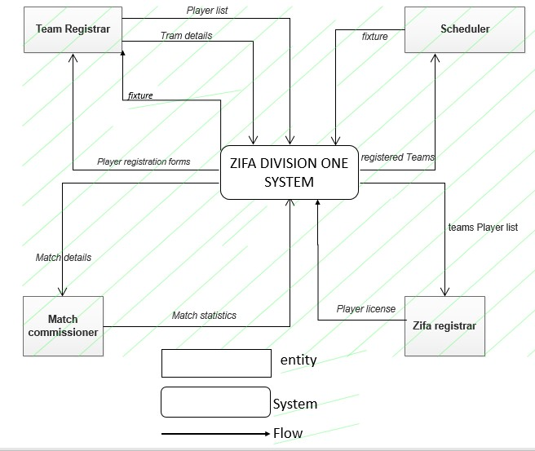

Being a manual system, the system has got a number of problems that are associated with manual system. Below are some of the problems:

1. It is expensive to continue using this system because the Association has to continue buying stationery.
2. The manual system is very slow in processing player registration.
3. The system is prone to many errors because of the large number of players that have to be dealt with.
4. The system is prone to unfair schedule distribution because of the large number of clubs that have to receive match schedule for the season.
5. Data captured is not secure as there are high probabilities that the papers maybe lost and it can be tempered with.
6. There are no backup storages for the data in the current system.
7. The system is prone to misleading log standings due to delay in recording of match statistics because there is a large number match recording that have to be dealt with.

**4.5.0 Conclusion.**

It is obvious from the choices researched during the analysis phase and those existing solutions examined above that none have met the requirements that Zifa MashEast demands, and conclusively a bespoke web application developed solely for Zifa MashEast is justified. Analysis of all this information will help the developer to come up with a system to meet the user requirements. In the next phase the system developer will start the design of the new system.

# CHAPTER FIVE

## Design

### 5. Introduction

With a close analysis of the system under the belt, it can now be assumed the functionality of the proposed system is fully comprehended and the analyst can now attack design details of the proposed system. The system design phase focuses on the development of the objectives of the proposed system and outlines how the proposed system is going to be developed, configured and deployed. In a nutshell, the phase outlines the Architectural design, physical design of Class hierarchy diagrams, Object diagram, State diagram, Sequence diagram and the Database design.

## Architectural design

A centralized system is going to be put in place at Zifa Mash East and the system architecture is client server relationship. This is the ideal architecture especially for a medium sized project. The following will make up the system.

**5.1.1 Client Machines:**

These are also known as workstations or PCs and that’s where the browser Applications sit on. These are the computers that are going to be used by ordinary users, mostly Registrars, Match Commissioners.

**5.1.2 Server:**

This machine will have the Apache web server installed, and Internet Information services, MySQL and PHP. MySQL database is ideal because of its capacity to handle large volumes of data, Apache is for web services and PHP is for server side scripting.

### 5.1.3 Network Topology

The proposed system will be making use of any configuration that has access to the World Wide Web. With the setup of the Digital Soccer System, it will actually blend in quite well with the set up to allow web viewing and use of the application.

### 5.1.4 Network Architecture

The client-server architecture will be used. This type of architecture separates the client (GUI) from the server. The web server apache will be hosted either on a remote or a local location but users will access the pages and form over the HTTP: The server will be managing intensive application tasks but clients will be carrying out some processing activities.

## Fig 5.1

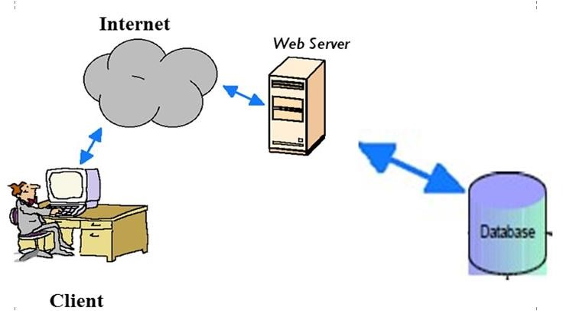

**5.2.0 Class Diagram of the System**

## Fig 5.2

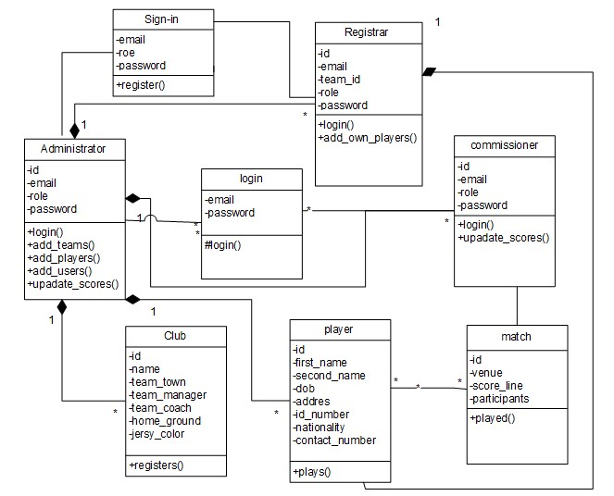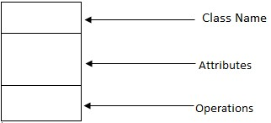

### 5.2.1 Object diagram

*Fig 5.3*

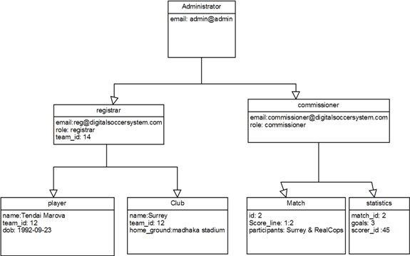

## Use case for Match Fixture development Fig 5.5

**Fig 5.6**

**Use case for Match Statistics recording**

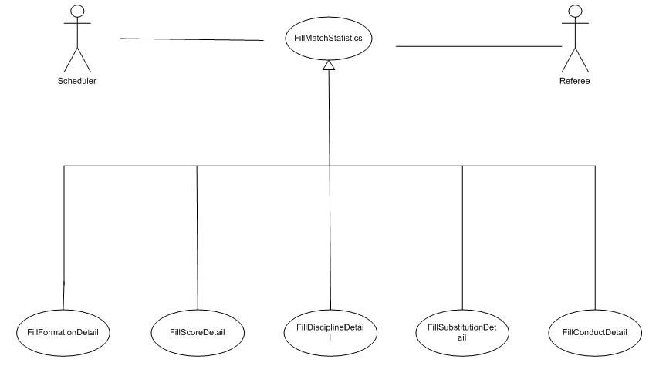

***Figure 3.7***



***Generate Report Use Case***

### 5.2. Sequence Diagram for Player Registration Fig 5.3

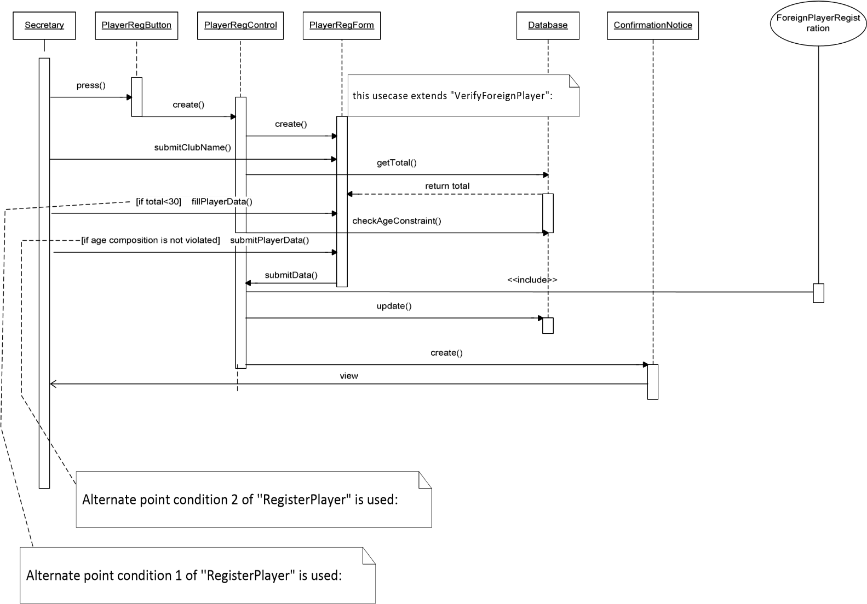

### 5.2 Sequence Diagram for Match statistics recording

***Fig 5.4***

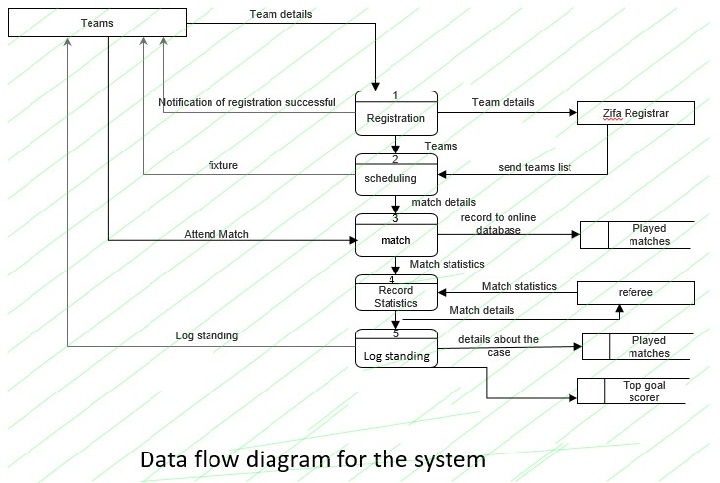

Re

~~feree/C~~

omiss

### 5.3 Database Design

On this stage the developer was focusing on the database architecture, he illustrated the database the database schema and the concept in form of tables. The system was designed using MySQL Database. Below is a sample of tables in their basic normalized forms. Field Name refers to the attribute name, data type refers to the data type of the attribute and the description is just an optional statement.

## Table Users table

|  |  |  |
| --- | --- | --- |
| **Field Name** | **Data Type** | **Description** |
| Email | Varchar | User identification Email |
| Password | Varchar | User password |

## Table players Table

|  |  |  |
| --- | --- | --- |
| **Field name** | **Data type** | **Description** |
| full name | varchar | Full Name of the player |
| Id-number | varchar | National identity number |
| age | int | Player age |
| Address | varchar | Address of the player |
| Team_id | int | Team which is currently playing for |
| dob | varchar | Date of birth of the player |
| Cell number | varchar | Contact number of the player |

<?php include "header.php";

$conn=mysql_connect("localhost", "root", "") or DIE('Connection to host is failed, perhaps the service is down!'); //Select the database mysql_select_db("football",$conn) or DIE('Database name is not available!'); R::setup('mysql:host=localhost;dbname=football', 'root', ''); //for both mysql or mariaDB

$id = @$_GET['team']; if(isset($_SESSION['sess_user'])){

?>

<h4 align="center">welcome <?=$_SESSION['sess_user']; }?></h4>

<div class="col-md-8 col-md-offset-2">

<div class="panel panel-primary">

<div class="panel-heading" style="background-color:green">Add Players for <?php

echo R::load('team', $id)->name; ?> </div>

<div class="panel-body">

<form method="post" action="" enctype="multipart/form-data">

<div class="form-group">

<label>FIRST NAME</label>

<input type="text" name="fname" class="form-control" required="required">

</div>

<div class="form-group">

<label>LAST NAME</label>

<input type="text" name="sname" class="form-control" required="required">

</div>

<div class="form-group">

<label>POSITION</label>

<input type="text" name="position" class="form-control" required="required">

</div>

<div class="form-group">

<label>PHONE NUMBER</label>

<input type="text" name="cell_number" onkeypress='return numbersOnly(this,event,false,true);' class="form-control" required="required">

</div><div class="form-group">

<label>RESIDENTIAL ADDRESS</label>

<input type="text" name="address" class="form-control" required="required">

</div>

<div class="form-group">

<label>DATE OF BIRTH</label>

<input type="date" name="dob" class="form-control" placeholder= "2017-0601" required="required">

</div>

<div class="form-group">

<label>NATIONAL ID NUMBER</label>

<input type="text" name="id_number" class="form-control" required="required">

</div>

<div class="form-group">

<label>NATIONALITY</label>

<input type="text" name="nationality" class="form-control" required="required">

</div>

<div class="form-group">

<label>Add Photo</label>

<input name="image" type="file" required="required"> </div>

<input type="hidden" name="id" value= "<?php echo $id; ?>"class="formcontrol">

<span><?php echo @$message; ?></span>

<p></p>

<input type="submit" name="save" class="btn btn-primary pull-right" value="ADD PLAYER" style="background-color:green"/>

<INPUT type="button" value="Cancel" class="btn btn-primary

pull-left" onClick="window.location.href='info.php'" style="background-color:green"/>

</form>

<?php if (isset($_POST['save'])) { $id = $_REQUEST['id'];

$team = R::load('team', $id);

$player_team =$team-> name;

$filetmp= $_FILES['image']['tmp_name'];

$filename = $_FILES['image']['name'];

$filetype = $_FILES['image']['tmp_name'];

$filepath= "uploaded_pictures/".$filename; $date = date('Y-m-d H:i:s'); move_uploaded_file( $filetmp,$filepath);

$player = R::dispense('player');

$player->fname = $_POST['fname'];

$player->sname = $_POST['sname'];

$player->position = $_POST['position'];

$player-> id_number = $_POST['id_number'];

$player-> address = $_POST['address'];

$player-> cell_number = $_POST['cell_number'];

$player-> dob = $_POST['dob'];

$player-> nationality = $_POST['nationality'];

$player-> img_name =$filename;

$player-> team_name =$player_team;

$player-> date_registered = $date;

$player->image_path = $filepath;

$player-> img_type= $filetype;

$team->ownProductList[] = $player; R::store($team); echo '<img src="img/492.png" /> &nbsp;! player information saved successfully';

include "footer.php"; ?><script> function numbersOnly(Sender,evt,isFloat,isNegative) {

if(Sender.readOnly) return false; var key = evt.which || !window.event ? evt.which : event.keyCode; var value = Sender.value;

if((key == 46 || key == 44) && isFloat){ var selected = document.selection ? document.selection.createRange().text : ""; if(selected.length == 0 && value.indexOf(".") == -1 && value.length > 0)

Sender.value += ".";

return false;

}

if(key == 45) { // minus sign '-' if(!isNegative) return false; if(value.indexOf('-')== -1) Sender.value = '-'+value; else Sender.value = value.substring(1); if(Sender.onchange != null) { if(Sender.fireEvent){

Sender.fireEvent('onchange');

} else {

var e = document.createEvent('HTMLEvents');

e.initEvent('change', false, false);

Sender.dispatchEvent(e);

}

}

var begin = Sender.value.indexOf('-') < -1 ? 1 : 0; if(Sender.setSelectionRange){

Sender.setSelectionRange(begin,Sender.value.length);

} else { var range = Sender.createTextRange(); range.moveStart('character',begin); range.select();

} return false;

}

if(key > 31 && (key < 48 || key > 57)) return false;

}

</script>

## Integrity Constraints

The structure described for the database contains links between the tables through the use of primary and foreign keys. Primary keys are unique Identifiers (called *id* in each table) and exist solely to identify each record in a table; foreign keys are references to primary keys in other tables that form the basis of a relationship [25]. Referential Integrity is enforced by ensuring that when an entity is created, that the relationship to another entity is in place (i.e. the other entity exists).

### 5.3.1 Normalisation

The database must be normalised to ensure that data is not repeated, and attributes do not contain multiple values. Normalised data is integral in ensuring the database works efficiently and without error. The initial data was converted to 1Normal Form (1NF) by removing multiple values in attributes such as Kit, where the information was separated from 1 large value containing all the kit colours, to 3 separate kit pieces “socks”, “shirts” and “shorts”. Every non-key attribute also had to be referenced by a primary key; this was solved by the addition of the *id* attribute for each table. 2NF was achieved by ensuring that any attribute within an entity could be identified by the primary key, and nothing but the primary key. An example of this is the Team and Ground tables, before 2NF was established, a Team could be identified by the Ground it played at, but as many teams could play at 1 Ground this did not uniquely identify it. By separating Team and Ground in to separate tables meant 2NF was achieved. 3NF was achieved by removing attributes that are not fully dependant on the primary key. This was done in the Players table which had “Total” attributes for both appearances and goals. These “Total” fields were removed as they can be calculated on the fly, and do not need to be stored. This brought the database into Normalised Form. It was initially difficult to model the relationships between Players, Squads and Teams, but after some additional consultation with ZIFA MASHEAST the relationships were modelled, which meant that a Player belonged to a Squad, of which had many Teams. A Player usually played for a single team but on some occasions it was possible they may play for another Team in the same Squad for instance a Player earning enough credit to be promoted from the 2nd Team into the 1st team.

### 5.3.2 Administration and Form Design

The administration area of the system will be accessed through username and password tokens, and will allow authorised users to add, manipulate or delete data within the database. Data will be added through a series of clearly labelled forms, and provide the user with a very simple and non-technical method of adding data without them having to change HTML code, or prior knowledge of web development. This simplicity will allow admin users of all technical backgrounds and abilities update the website easily. The main administration page will be easily navigable, simple and favour usability and functionality over appearance. Appearance will not totally be ignored as an effective appearance can increase the usability but the appearance won’t simply be there to please the eye.

### 5.4 Interface Design

The interface will be the interaction between the system and the users. It has been designed to be user friendly, intuitive and must ensure that data is recorded easily and correctly. The interface design defines the way users will interact with the system and the nature of the inputs and outputs that the system is associated with. This particular one has been structured with HTML with CSS rules for styling the interface. The interface is equipped with forms that enable a user to send records to the database and retrieve them as necessary. The interface is going to be window forms (GUI) and thus all the communication between the user and the system will be through these forms, windows and pop-up menus. The basic interface design for the system is as follows:

**MENU**

**HOME**

**TEAMS**

**LOG STANDING**

**RESULTS**

**MATCHES**

**LOGIN**

On all the windows that will be in the application the following will be considered for the interface:

1. Familiarity to the user: the interface will use the terms and concepts that are drawn from user experience and anticipations that the user will not be confused by the system.
2. Consistency: the interfaces will not be intermittently altered without user notification and similar interfaces will be activated in the same way at every request.
3. Recoverability*:* The interface should provide information for the user to recover from various application or database errors and not keeping the user stuck. user panic when errors arise or users need help, instead it should incorporate some form of context sensitive guidance assistance.

#### 5.4 Input Design

The forms are designed to capture data and send it to the respective database or queries. The input forms are designed to be user friendly and to facilitate accurate capture and updating of data. Error messages should be displayed on the surface around the field of entry of data. And the data should be re-entered. Multiple Submissions of the same form and submission of wrongly filled forms should be controlled by the system. Users will be able to switch between the various MDI child forms during input of data.

The following will hold for all input windows:

1. Data will be validated before being accepted by the system to ensure that correct and standardized data is stored within the database.
2. Keyboard keys will be used to perform functions that can be performed by a mouse like tab, enter and the backspace key to go to the previous page.

##### 5.4.1 Login Input Window

This input interface should bar unauthorized access to the system. Users should be prompted to enter user names and password and their different access levels. When running the system first to appear is a login form. Below is the design of the login window. Failure to give the correct user name and password will result in access being denied.

**Login Here**

Email address

Password

LOG IN

CANCEL

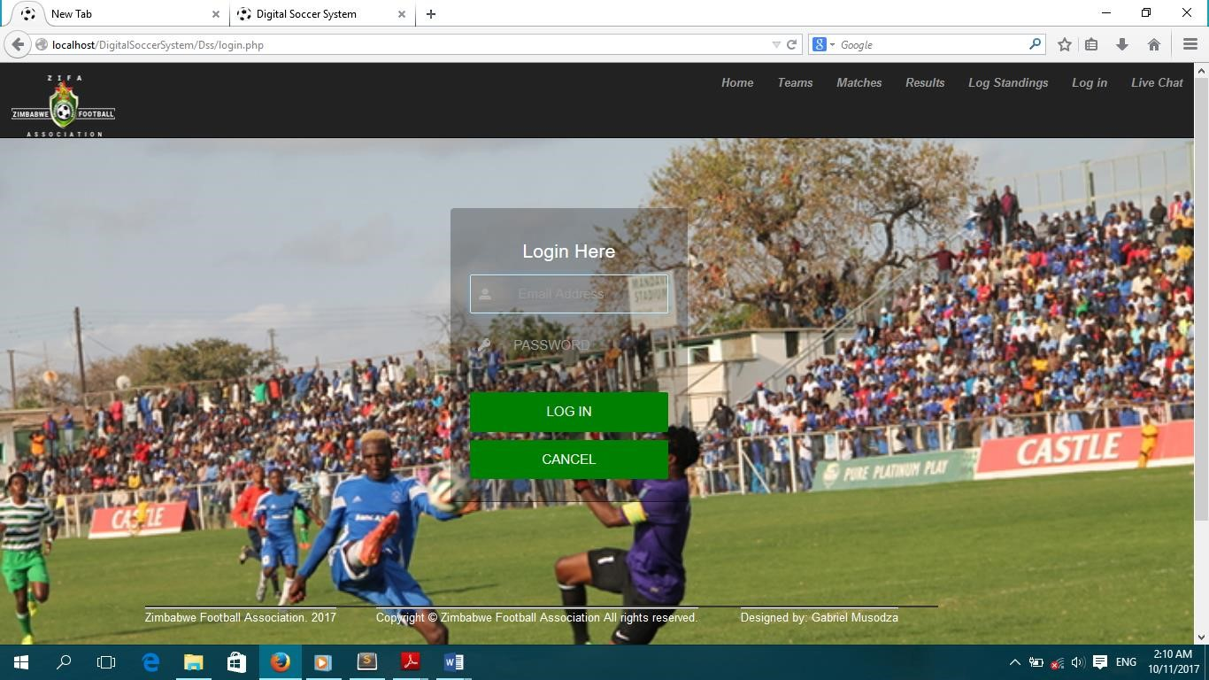

<html><head><link rel="stylesheet" type="text/css" href="css/style2.css"></head><?php include "header.php";R::setup('mysql:host=localhost;dbname=football', 'root', ''); //for both mysql or mariaDB if (isset($_POST['save'])) {

$_SESSION['last_login_timestamp'] = time();

$email = $_POST['email'];

$password = md5($_POST['password']);

$activity="Log in";

$Time=time();

$init = R::findOne('user', 'email = ? AND password = ?', [$email, $password]); if ($init == null) { print ("<script>window.alert('invalid details')</script>"); print ("<script>window.location.assign('login.php')</script>");

} else

$_SESSION['role'] = $init->role;

|  |  |  |  |
| --- | --- | --- | --- |
| $_SESSION['email'] | = | $init->email; | |
| sess_user']=$email; |  | $_SESSION[' | |
| team'] = $init->team;  // $fixture_id = $fixture;  $email = $_POST['email'];  $act = $activity;  $Time=time(); $audit = R::dispense('audit');  $audit->user_email = $email;  // $audit->home_scorer_id = $home_scorer_id;  $audit->activity = $act;  $audit->time_used = $Time;  R::store($audit); |  | $_SESSION[' | |
|  |  |  | //print |

("<script>window.alert('login successfull')</script");<div class="alert alert-warning alertdismissible" role="alert">

echo '<div

class="alert alert-success" role="alert" style="background-color:transparent">...<h2 style="color:white"> <img src="img/492.png" />

!login successfull </h2></div>'; echo ' <h2 align="center">

<meta content="2;index.php" http-equiv="refresh" />

</h2> ';

}

?> <div class="form-wrapper">

<h3 style="color:#FFFFFF" align="center">Login Here</h3>

<form method="post" action="login.php">

<div class="form-group form-item" >

<input type="email" name="email" class="form-control " placeholder=" Email Address" autofocus required>

</div>

<div class="form-group form-item">

<input type="password" name="password" class="form-control" placeholder="PASSWORD">

</div> <div class="button-panel">

<span><?php echo @$message; ?></span>

<input type="submit" name="save" class="button" value="LOG IN"

style="background-color:green"/>

<INPUT

type="button" value="Cancel" class="button" class="btn btn-primary pull-left" onClick="window.location.href='index.php'" style="background-color:green"/> </div>

</form>

<div class=" Footer navbar navbar-fixed-bottom ">

<div class="container"><?php include "footer.php";

?>

</div></div>

</div>

</html>

**Chapter Six**

### Coding and Testing

#### 6.0 Introduction

In the previous section, the various designs were laid out and a workable one was decided on which shall now be implemented. There has also been given an outline of how the input and output of the proposed system will be like. In this chapter, the developer exhibits sample codes that will help in getting what expected output from the system and the various ways in which the new system can be tested and these are discussed in this section.

##### 6.1 Coding

This section we will discuss the programming language that will be used for development, programming style, data storage, connection method, processing method as well as the input and output methods.

<?php

include "header.php";

R::setup('mysql:host=localhost;dbname=football', 'root', ''); //for both mysql or mariaDB function show_fixtures($names)

{

$teams = sizeof($names); print "<p>Fixtures for $teams teams.</p>";

$ghost = false; if ($teams % 2 == 1) {

$teams++;

$ghost = true;

}

$totalRounds = $teams - 1;

$matchesPerRound = $teams / 2;

$rounds = array(); for ($i = 0; $i < $totalRounds; $i++) {

$rounds[$i] = array();

}

for ($round = 0; $round < $totalRounds; $round++) { for ($match = 0; $match < $matchesPerRound; $match++) {

$home = ($round + $match) % ($teams - 1);

$away = ($teams - 1 - $match + $round) % ($teams - 1);

// Last team stays in the same place while the others // rotate around it.

if ($match == 0) { $away = $teams - 1;

}

$rounds[$round][$match] = team_name($home + 1, $names)

. " v " . team_name($away + 1, $names);

}

}

$interleaved = array(); for ($i = 0; $i < $totalRounds; $i++) {

$interleaved[$i] = array();

}

$evn = 0; $odd = ($teams / 2); for ($i = 0; $i < sizeof($rounds); $i++) { if ($i % 2 == 0) {

$interleaved[$i] = $rounds[$evn++];

} else {

$interleaved[$i] = $rounds[$odd++];

}

}

$rounds = $interleaved;

for ($round = 0; $round < sizeof($rounds); $round++) { if ($round % 2 == 1) {

$rounds[$round][0] = flip($rounds[$round][0]);

}

}

for ($i = 0; $i < sizeof($rounds); $i++) { echo "<div class='col-md-6'> <div class='panel panel-primary'>"; print "<div class='panel-heading'><p>Round " . ($i + 1) . "</p></div>"; foreach ($rounds[$i] as $r) { print $r . "<br />";

$pieces = explode(" v ", $r);

$init = R::findOne('fixture', ' home = ? AND away = ?', [$pieces[0], $pieces[1]]); if ($init == null) {

$fixture = R::dispense('fixture');

$fixture->home = $pieces[0];

$fixture->away = $pieces[1];

$fixture->status = "TBP";

$fixture->homescore = 0;

$fixture->awayscore = 0;

R::store($fixture);

}

}

print "</div></div>";

}

print "<br /><div class='col-md-12'><p>Second half of the season</p></div>";

$round_counter = sizeof($rounds) + 1; for ($i = sizeof($rounds) - 1; $i >= 0; $i--) { echo "<div class='col-md-6'> <div class='panel panel-primary'>"; print "<div class='panel-heading'><p>Round " . $round_counter . "</p></div>";

$round_counter += 1; foreach ($rounds[$i] as $r) { print flip($r) . "<br />";

$pieces = explode(" v ", flip($r));

$init = R::findOne('fixture', ' home = ? AND away = ?', [$pieces[0], $pieces[1]]); if ($init == null) {

$fixture = R::dispense('fixture');

$fixture->home = $pieces[0];

$fixture->away = $pieces[1];

$fixture->status = "TBP";

$fixture->homescore = 0;

$fixture->awayscore = 0;

R::store($fixture);

}

}

print "</div></div>";

} print "<br />";

if ($ghost) { print "Matches against team " . $teams . " are byes.";

}

} function flip($match)

{

$components = split(' v ', $match); return $components[1] . " v " . $components[0];

} function team_name($num, $names)

{

$i = $num - 1; if (sizeof($names) > $i && strlen(trim($names[$i])) > 0) { return trim($names[$i]);

} else { return $num;

}

}

$teams = R::findAll('team'); $names = array(); foreach ($teams as $name) { array_push($names, $name->name);

} show_fixtures($names); include "footer.php";

?>

###### 6.1.1 Programming language

The proposed system will be developed using PHP programming language. This is because PHP is probably the most popular scripting language on the web. It is used to enhance web pages. With

PHP, you can do things like create username and password login pages, check details from a form, create forums, picture galleries, surveys, and a whole lot more. It is even possible to chart data and create PDF documents on the fly.

PHP is known as a server-sided language. That's because the PHP doesn't get executed on your computer, but on the computer you requested the page from. The results are then handed over to you, and displayed in your browser. So since we want a web based system PHP would be the best language to use.

###### 6.1.2 Programming style

There are many approaches to system development that can be used but we will use the Structured Approach to Analysis and Design in our implementation. In implementing this approach, we will use the Top-down Approach together with Modular programming.

6.1.2.1. The Top-Down Approach

This approach allows us to ascertain overall organizational objectives along with ascertaining how they are best met in the overall system. The system will be divided into subsystems and their requirements.

## Advantages of the Top-down approach

It allows us to avoid the chaos of attempting to design the system “all at once”.

It gives us the ability to have separate systems analysis teams working in parallel on different but necessary subsystems.

It eliminates losing sight of the system as a result of getting so mired in detail.

## Disadvantages

There is a danger that the system will be divided into the wrong subsystems.

Once subsystem divisions are made, their interfaces may be neglected or ignored.

The subsystems must be reintegrated, eventually.

### 6.1.2 .1 The Top-Down Design of the proposed system

The proposed system will be decomposed into six subsystems, each of which will be divided into subtasks. The six subsystems of the proposed system will be as follows:

1. **File** – This will enable creation of new records and saving of backup files.
2. **Queries** – This will allow the querying of database tables to produce relevant data.
3. **View/Edit** – This will allow the viewing and editing of records.
4. **Print** – This will allow the printing of reports, all account details. The print function will be enabled by the browser’s print button.
5. **Security options** – This will enable users to change their passwords as well as the information systems manager to add new users to the system.
6. **Exit** – This will allow users to exit the system by showing the log out dialogue box.

The proposed system will make use of Modular programming and the Top-down approach. Modular programming concept is useful for the top-down approach. Once the top-down design approach is taken, we will break the whole system into logical, manageable sized modules or subprograms in order to use modular programming techniques.

## Advantages of modular programming

* Modules are easier to write and debug.
* Tracing an error in a module is less complicated.
* Modules are easier to maintain.
* Modules are easier to grasp because they are self -contained subsystems.
* It is to modify or insert modules.
* As individual programmers and design, we can be given different modules and work independently of each other.

### 6.2 Testing

Before the system can be installed on a client’s machine it is essential to conduct tests so as to check for errors such as syntax errors and some errors which might compromise on the quality of the system.

The testing was carried out in the following phases:

* Unit testing
* Module testing
* System testing
* Acceptance testing

#### 6.2.1 Unit testing

The testing technique focuses on a unit of the program which can either be a function or a module.

Two different techniques that we used for the unit testing and these are:

**Black box testing**- this involved testing of the inputs and outputs produced by the system without taking into consideration the internal operations of the system. This involved checking outputs such as reports to verify whether they were producing the required outputs.

**White box testing**- this pays detail to the internal processes of the system. It focuses on the internal working detail of a unit and identifies errors not shown through black box.

#### 6.2.2 Module testing

This is also called link testing. It tests a collection of intergraded module into a subsystem. It ensures job streams are correct. There is detection of interface mismatches and rigorous exercise of the interface between programs. The modules, which are linked together, were tested.

#### 6.2.3 Interface testing

In this section the following conclusions were drawn about the interface:

* All data content contained within the window is properly addressable with a mouse function keys and keyboard shortcuts.
* All functions that relate to the windows are available when needed.
* All the windows close properly.
* All tools on interface serve a function.
* All relevant pull-down menus, tool bars, dialog boxes, buttons, icon, and other controls are available and properly displayed for the windows.
* All the information needed from the user is accessible from the interface tools, i.e can the interface effectively accept.

#### 6.2.4 System testing

This testing technique involves cycle tests all programs and ensure that everything necessary is in place for instance proper documentation. It involves testing of the whole system to measure efficiency and effectiveness of the system. It is essential to measure the systems functionality with stated objectives and this is done during the process of system testing. Functions such as security and output generation will be taken into account as users go through the system. There are also other issues that are taken into consideration such as compatibility of the software to the hardware and how the system will adapt to computer threats.

## Testing phases outline

### 6.2.5 Acceptance testing

The users needed to accept the system and they can only do so after they have tested the system themselves. This is one of the final stages before the system is accepted for use. In this stage errors and omissions that the developers might have missed are discovered. The system will be installed to a sample group of users who will provide feedback on the systems functionality. **Sample tests results**

## Test 1

This test verifies the input that was placed in the field controls, for instance a user can be verified whether he/she is one of the registered users to the system. If the user is not a registered user, then the system will deny him/her rights.

In this case wrong information was entered and the following is what came out:It gave an error message and prompts you to retry or go through the registration process if you are not registered.

**Test 2: Can one access anything?**

Before your login your access level is known as role in session and then you are directed only to the applications and service of that role level and if you don’t possess the login details for certain particular role you will not access some information. And below it a screenshot of the system output as admin.

### 6.3 Verification and Validation

#### 6.3.1 Validation

The goal of this test is to ensure that the clubs Relationship satisfies the Association requirements and solved the association’s problems. It is concerned about building the right system which sufficiently serves its purpose. The data to be entered by the end users had to be validated to make it easier for them to use this system for example the national ID number could only be used with the accepted format of the Zimbabwean Id number and the date of birth could not be just any number, only dates are acceptable. To ensure that the test was performed to accuracy, the system was given to “pseudo users” together with the user specifications. After running the system adjustments were then made in accordance with the “pseudo users” comments and complaints.

#### 6.3.2 Verification

It is concerned with building the system right, ensuring that data captured is true ,accurate and consistent. To do this the desired outcome on paper was continuously being checked to see if its desired objectives stated in chapter one and the functionality stated in chapter three tallied with the developed system. The system tallies with the exact systems requirements desired by the Customer Services Department as proved by the testing phase.

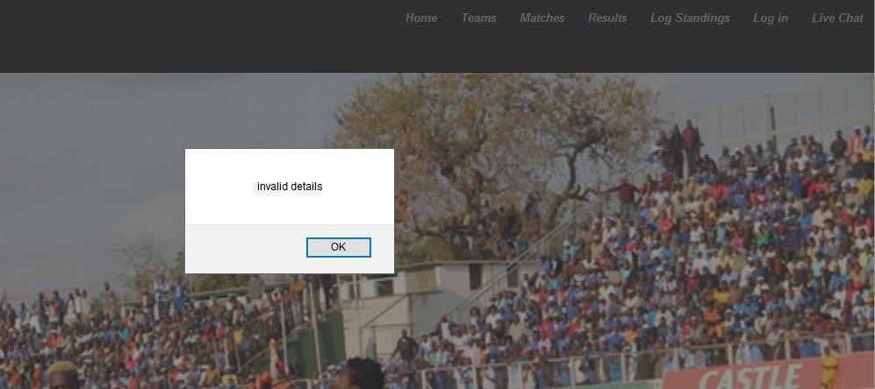

<html>

<head>

<link rel="stylesheet" type="text/css" href="css/style2.css">

</head> <?php

include "header.php";

R::setup('mysql:host=localhost;dbname=football', 'root', ''); //for both mysql or mariaDB if (isset($_POST['save'])) {

$_SESSION['last_login_timestamp'] = time();

$email = $_POST['email'];

$password = md5($_POST['password']);

$activity="Log in";

$Time=time();

$init = R::findOne('user', 'email = ? AND password = ?', [$email, $password]); ($init == null) {

// $message = "invalid details"; print ("<script>window.alert('invalid details')</script>");

print ("<script>window.location.assign('login.php')</script>");

} else

$_SESSION['role'] = $init->role;

$_SESSION['email'] = $init->email;

$_SESSION['sess_user']=$email;

$_SESSION['team'] = $init->team;

// $fixture_id = $fixture;

$email = $_POST['email'];

$act = $activity;

$Time=time();

$audit = R::dispense('audit');

$audit->user_email = $email;

// $audit->home_scorer_id = $home_scorer_id;

$audit->activity = $act;

$audit->time_used = $Time; R::store($audit);

alert-warning alert-dismissible" role="alert"> echo '<div class="alert alert-success" role="alert" style="background-color:transparent">...<h2 style="color:white"> <img src="img/492.png" />

!login successfull </h2></div>';

echo ' <h2 align="center">

<meta content="2;index.php" http-equiv="refresh" />

</h2> '; // print ("<script>window.location.assign('index.php')</script");

}

?>

<div class="form-wrapper">

<h3 style="color:#FFFFFF" align="center">Login Here</h3>

<form method="post" action="login.php">

<div class="form-group form-item" >

<input type="email" name="email" class="form-control " placeholder=" Email Address" autofocus required>

</div>

<div class="form-group form-item">

<input type="password" name="password" class="form-control" placeholder="PASSWORD">

</div>

<div class="button-panel">

<span><?php echo @$message; ?></span>

<input type="submit" name="save" class="button" value="LOG IN" style="backgroundcolor:green"/>

<INPUT type="button" value="Cancel" class="button" class="btn btn-primary pull-left" onClick="window.location.href='index.php'" style="background-color:green"/>

</div>

</form>

<!-- <p style="color:white">Don't have an account? <a style="color:#FFFF00" href="register.php">Sign up now</a></p>-->

</div>

</div>

</header></div>

<div class=" Footer navbar navbar-fixed-bottom ">

<div class="container">

<?php include "footer.php";

?>

</div></div></div></html>

### Chapter 7

#### 7.0 System Installation

To install the system, for the tests and training

Get the file from the device using a flash and

Click My Computer on the desktop and right click the mouse.

Click Explore to view all the drives on your computer.

Select Compact Disc (D:) or flash drive and right click the mouse as above. This time you can choose either Open or Explore.

Select project and copy it.

Go where the server is located and open it and paste it in the folder www as follows C:\Program Files\EasyPHP1-8\www\test

Use either wamp or xampp of these servers’ tart the control panel so that your server will start running.

Set the systems home page to be the default page when you start internet explorer.

Double click internet explorer on the desktop to access the system.

You can then safely run the program

**7.0.1 To install and host the system for final use.**

The final installation stage involves the uploading and hosting of the Digital Soccer System web based system on to the web server to enable online access to everyone.

1. Click the "File" menu followed by the "Site Manager" item on the menu. A dialog box will appear.
2. Click the "New Site" button on that dialog box. This creates a new item under

"My FTP Sites" called "New FTP site". Rename "New FTP site" to the name of your site if you wish. By default, the keyboard cursor would have been placed in the name portion of "New FTP site" allowing you to change the name immediately. If you have lost the cursor because you accidentally clicked somewhere else in the dialog box, you can get it back by simply clicking once on the name. Note that this name can be anything you wish - it is not required for accessing your site. However, you will probably make your life easier if you change the name to that of your site rather than the cryptic "New FTP site".

1. Under the tab "General", enter the name of your FTP server in the "Host" input box. Enter the hostname into the space provided.
2. Leave the "Port" and the "Server type" entry boxes alone. Use your mouse and select "Normal" from the drop down list box for "Logon type". This will enable the "User" and "Password" boxes for the next step.
3. Enter your user id or your login name (or whatever your web host calls it) into the "User" input box. Likewise, enter your password into the "Password" input box. Note that this information is automatically saved onto your computer and will be re-used the next time you run FileZilla, so you do not have to re-enter them again. (It also means that you should not use FileZilla in this way on computers that others may have access to, such as those found in an Internet cafe or a public library.)
4. Click the "Connect" button. FileZilla will proceed to log you into your server. If it is successful, you will see a directory listing of your website's account in the right hand side of the FileZilla window. The left hand side of the FileZilla window shows the directories and files on your own computer.
5. Only upload a specific subdirectory on the web server, such as in the "www" or "public_html" directory, change to that directory by double clicking its name in the folder portion of the right window pane (the "Remote Site" window pane).

FileZilla will open that folder and show you its contents in the files portion of the Remote Site window pane.

1. Next, locate the file that you wish to upload in the left window pane (the "Local Site" pane). Both window panes behave mostly like a Windows Explorer windows, so navigating them should not be unduly hard. Once you have located the files you wish to upload, double click it to upload it to your website.

Alternatively, you can drag that files from the left window pane to the right window pane. The file will be uploaded to the folder that is currently open on the right window pane, so make sure you have changed to the directory you want before dragging the file there.

1. As FileZilla proceeds to upload your file to your site, you should be able to see the upload progress in the bottommost window pane in FileZilla. When the upload has completed, you can disconnect from your website. Do this by clicking the "Server" menu followed by the "Disconnect" item.

Congratulations! You have successfully uploaded a file to your website using an FTP client, FileZilla.

#### 7.1 Methods of conversion

Several methods were taken into account before selecting the best conversion method to use.

The methods that were taken are as follows:

Pilot conversion

Direct conversion

Parallel conversion

##### 7.1.1 Pilot conversion

Pilot is a selective implementation method. Installation of the new system is to those to those departments that require the use of the system. Cost is relatively moderate since only one or two locations run both systems. Risk is also relatively moderate when this method is used.

##### 7.1.2 Direct conversion

This conversion method sees a complete overhaul in use of the existing system. The new system is then implemented and starts operating.

The old system is completely done away with as people shift into the use of the new system.

This strategy has relatively low cost of implementation, however there is an

Imminently high risk of the new system failing to meet the requirements or fail to give better functionalities than the old one.

##### 7.1.3 Parallel conversion

This involves running the two systems together at the same time. This gives the user a better background to the new system and also backup to refer to in case the new system fails. The implementation costs are relatively high as both systems will be operating simultaneously for the whole changeover period specified. Risk is relatively low due to the existence of backup from the old system still in operation.

##### 7.1.4 Decision

The parallel conversion method was the most favoured so both the new and existing systems will run in parallel for a period not exceeding twelve months after which feedback on the performance between the two systems will be provided for adjustments if necessary.

#### 7.2 Training

Training was provided to the end users before using or operating the system. To assist with the training, a user manual was provided. For **User Manual** refer to **Appendix.** Training was provided in-house by the system developer. Users of the system. After training, the users were asked to operate the system in presence of system developer. This was done to monitor his/her progress and comfort ability with the system. It was discovered that user was confident with system and was impressed with the functionality of it.

Training was done at two levels

* Personal or Module level: This is for the particular modules that concern the particular users.

Password as supplied by the developer

* Organizational or System Level This was mainly for the management who has to appreciate the development of the system and its functions across organizational departments. In addition, users who have access rights to all modules also had to be versed with the functions of the entire system.

#### 7.3 Maintenance

Regardless of how well designed, constructed and tested a system or application maybe, bugs or errors will inevitably occur. Bugs can be caused by any of the following:

Poorly validated requirements.

Poorly communicated requirements.

Misinterpreted requirements.

Incorrectly implemented requirements or designs.

Simple misuse of the programs and malicious input.

The fundamentals of the system maintenance will thus be:

To make predictable changes to the existing programs to correct errors that were made during systems design or implementation.

To preserve those aspects of the programs that were correct to avoid the possibility that

“fixes” to programs to cause other aspects of those programs to behave differently.

##### 7.3.2 System Maintenance

To carry out this stage, the following were checked for.

Response time- this is the overall time between a request for system activity and the delivery of the response by the system and the efficiency of the computer itself and this is the time from the input of a request to the CPU until the output is delivered to the system.

System review will ensure that the system meets the objectives. Periodic reviews will be held

to ensure that the system conforms to user’s expectations and requirements. It is used in checking the overall performance of the system. The importance of carrying system review is to ensure that the system functions according to the specified specifications.

The system needs to cope up with changes in external environment thus updating the system is necessary to cope up with new user requirements. There are three types of maintenance namely:

1. **Corrective maintenance** – Fixing errors reported by the systems users which could be coding errors, design errors, or requirements errors.
2. **Adaptive maintenance** – Altering the system to suit some new environments for example, different hardware platform or operating systems. Functionality does not radically changes. The enhancement will result from the ever-changing business environment in the banking sector. The general application software has to be changed if the different hardware platform or operating system has to be used. The system will be altered if the changing environment triggers a change to the system.
3. **Perfective maintenance** – This is carried out when there is need to change the whole system to make it more efficient. Implementing new functional or non-functional system requirement generated by users as their organization or business changes.This process ensures that the newly implemented system meets the system development objectives established for it. Errors in development or use of a system must be corrected by this maintenance process. In this stage, we will have periodic reviews with the users or the representatives of the organization to audit the system so as to ensure that it is operating properly and meeting its objectives. When a system has been implemented, monthly reviews will be held so that if there are any problems arising, they may be attended to as a matter of urgency. After a year, annually reviews will be held so that if there are any changes due to changes in the business environments, they may be attended to so that the system continues to meet business needs.

#### 7.4 Securities

##### 7.4.1 Physical Security

The servers and all client machines will be stored in locked rooms. The security features of this kind are already in place. The use of security guard will be implemented to ensure that the system will not be vandalised.

##### 7.4.2 Software Security

Authorization to access the system will be granted according to user levels and a user will also be required to supply a password before he/she can gain access to the system.

# CHAPTER 8

## 8.1 Summary

This document provides a detailed report of the project undertaken to solve problems experienced by ZIFA MASHEAST DIVISION ONE LEAGUE in facilitating registration of clubs and players, scheduling of matches and recording of match statistics and also sharing of league reports.

The primary aim was to implement a web-based information system which would assist collection, distribution and usage of information throughout the league. Information was to include scheduling of matches for the season, registration of clubs and players and recording of match reports. In an extension to the original requirements, an e- community (containing a member directory and chat forum), public website and online services, were also included as part of the overall solution.

Throughout the project, the importance of sustained end-user involvement was considered vital to success. The use of the Digital Soccer System methodology, supplemented by prototyping, allowed requirements to be continually re-defined and integrated into the system. An effective change management programme was also designed to ensure continued involvement and support from key stakeholders, who would ultimately decide upon project success/failure.

In order to create a system which would encourage and facilitate use by all members. The system was also implemented in a manner which permits future development/extension by the league. This was achieved through appropriate technology choices and a consistent coding style.

The people-based nature of the problem meant extensive organisational and information analysis were undertaken prior to design/implementation. A phased approach to development permitted simultaneous testing and development, increasing efficiency. While unit testing was completed by the developer, extensive end-user acceptance testing was also utilised to evaluate prototypes and the final system. A dedicated PTFC project team, made up of computer-literate club members, took responsibility for overseeing end-user testing and provided effective interface between the developer and

## 8.2 Conclusion

Sports like football have become a big business, with massive investments in players and structures. Professional and amateur leagues face challenges in management problems involving logistics, revenue maximization, schedule fairness issues and game attractiveness, among other aspects. Particularly, scheduling the games of the leagues is certainly the most difficult area of league management. It consists of determining the date and the venue in which each game will be played and also includes assigning referees to games.

Many Associations have been using the scheduling and registration system for their national soccer leagues. However, because of some specific constraints that characterize each of these competitions, the systems and the models used in those countries are not readily applicable to soccer league scheduling problems in Zimbabwe. In this project work we have analysed the existing manual league management system being utilized by the Zifa MashEast. Based on the information gathered we have designed and implemented a web based application that satisfies the constraints specified by the Federation. The prototype was also evaluated with real data from the federation and its performance was found to be very good.

## 8.3 Recommendation

Even if the system facilitates scheduling, registration and recording of match statistics, it doesn’t consider the distance between home cities of each club in scheduling the fixtures. Since the travel cost of fans and clubs is one of the issues to be taken into account in scheduling, there should be a way in the system to capture and handle the issues mentioned also to handle assignments of refrees to the matches.

# CHAPTER 9

## 9.0 Bibliography

1. Celso C. Ribeiro, and Sebasti Anurrutia*,Scheduling in Sports: an annotated bibliography graham kendall*, Sigrid Knust, 2009
2. http://www.informaworld.com/smpp/section?content=a775664576&fulltext=713240928 retrieved on March 23, 2011.
3. http://www.tessemas.net/Yidnekatchew%20&%20the%20%20F.I.F.A%20of%20Sir%20S tan ley.html retrieved on March 23, 2011
4. Dries Goossens and Frits C.R. Spieksma,*Scheduling the Belgian Soccer League*

Department of Operations Research, Katholieke Universiteit, Belgium,2006

1. Graham Kendall Barry McCollum, Frederico Cruz, Paul McMullan, *“Scheduling*

*English Football Fixtures: Consideration of Two Conicting Objectives*”, 2006 [6]

Rasmus V. Rasmussen, *Scheduling a triple round robin tournament for the best*

*Danish soccer league,*Department of Operations Research,University of Aarhus Denmark,2006 [7] T. Bartsch, A. Drexl, S. Kr¨oger, Scheduling the professional soccer leagues of Austria and Germany, Computers & Operations Research 33

(7)(2006) 1907–1937.

1. F.D. Croce, D. Oliveri, Scheduling the Italian football league: An ILP-based approach, Computers & Operations Research 33 (7)(2006) 1963–1974.
2. J.A.M. Schreuder, Combinatorial aspects of construction of competition Dutch Professional Football Leagues, Discrete Applied Mathematics 35 (1992)301–312.
3. Celso Ribeiro and Sebastián Urrutia,*Soccer scheduling goaaal*, Department of Computer

Science,Universidade Federal Fluminense, Brazil, 2010

1. G. Durán, M. Guajardo, J. Miranda, D. Sauré, S. Souyris, A. Weintraub, and R. Wolf, 2007, Scheduling the Chilean soccer league by integer programming, Interfaces, Vol.

37, pp.

539-552.

1. Trevor Hardy and Keith A. Willoughby *, Does the Number of Days Between Professional*   *Sports Games Really Matter?,*Edwards School of Business,University of Saskatchewan, Toronto, on Canada ,2009.
2. http://www.southafrica.info/news/sport/football-psl-030510.htm retrieved on March 04,2011.
3. http://www.soccersoftware.co.za/ retrieved on March 10, 2011
4. Víctor Muñoz, Miquel Montaner, Beatriz López *,Seat allocation for massive events based on region growing techniques*, Universitat de Girona,2004
5. http://www.softengi.com/docs/Presentation_SportsFusion_Applications_for_Sport.pdf, accessed on March 10, 2011
6. http://msdn.microsoft.com/en-us/vstudio/default.aspx, retrieved on April 19, 2011.
7. http://www.csharpcorner.com/UploadFile/mahesh/WebAppinVS200511152005020240 AM/

Web AppinVS2005.aspx retrieved on April 26, 2011

1. http://www.winsupersite.com/showcase/yukon_visualstudio2005.asp retrieved on April

2,

2011.

1. http://www.dell.com/downloads/global/power/ps1q06-20060126-Microsoft.pdf retrieved on March 26, 2011
2. Brown, S (2006)

*Final Year Project Report, Appendix A Reflections – University of Leeds*

# CHAPTER 10

## 10.0 Appendix 1

**Interview questions**

The following were interview questions that were prepared to raise discussion with personnel of the Zifa Mash East Division 1 league and some fans for the purpose of identifying requirements and to analyse the system.

1. How many types of competitions are found in the league?
2. How many clubs are allowed to participate in both Division 1 league?
3. How many teams are the in the league in this year?
4. Who are the workers that are directly related to the Division 1 league management and what are their roles?
5. How does the competition Organization committee prepare the season schedule?
6. How national games affect the schedule and haw do they take measure for that?
7. How do they calculate the league table, top goal scorers and other similar issues?
8. How do they store data and use of it?
9. How referees are assigned for each game?
10. How do the customers/fans know the fixture?
11. How do referees fill the match statistics?
12. How does discipline cases handled?
13. How do financial penalties imposed to clubs and players are taken care off?
14. How do players’ contracts accomplished?
15. How do the transfer zone is handled in the league?
16. How does the report of the competition prepared?
17. What are the challenges that have been happening in the existing system?
18. What are the challenges that the fans faced?
19. What additional new features do you wish from the new system? 10.1 Appendix 2

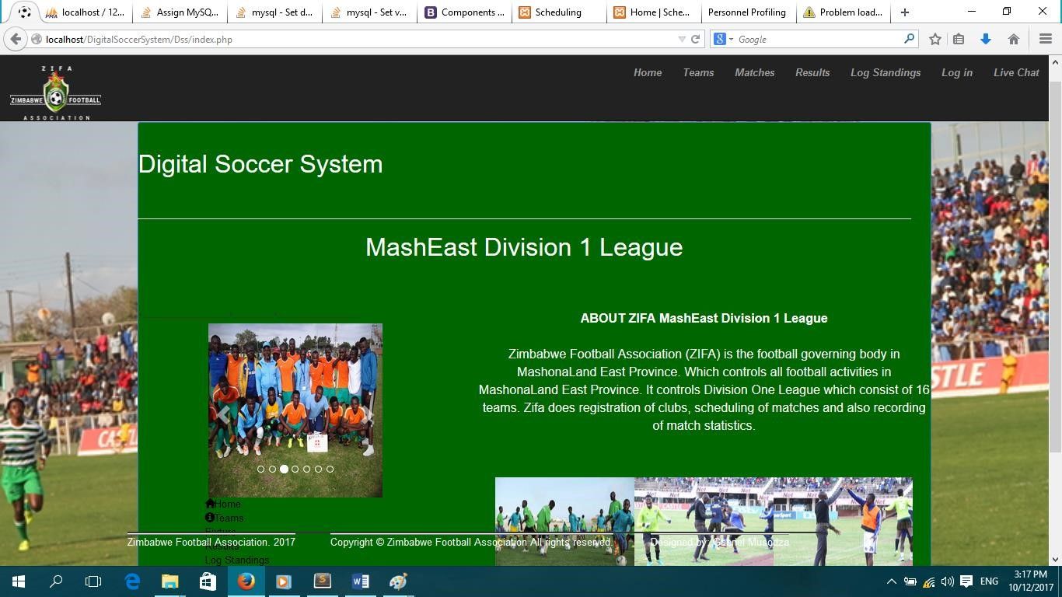

**Home page Code**

<?php include "header.php";

?>

<body>

<div class="col-lg-12 container" >

<div class="page-header">

<h1 style="color:white">Digital Soccer System </h1>

</div>

<h1 align="center" style="color:white">MashEast Division 1 League</h1> <br>

</div>

<div class="container">

<div class="panel panel-primary" style="background-color:#006600">

<div class="row">

<div class="col-md-4 " >

<div class="row " >

<div class="col-md-12 " >

<div class="customDiv sidebarContent " >

<?php include 'slider.php';?>

<ul style="color:white" >

<li ><a href="index.php"><span class="glyphicon glyphiconhome"></span>Home</a></li>

<li><a href="info.php"><span class="glyphicon glyphicon-infosign"></span>Teams</a></li>

<li ><a href="fixture.php">Fixture</a></li>

<li ><a href="results.php">Results</a></li>

<li><a href="log.php">Log Standings</a></li>

</div></div>

</div>

<div class="col-md-7 pull-right">

<div class="mainContent customDiv " style="color:white"><strong >ABOUT ZIFA

MashEast Division 1 League</strong><br></br> <p >Zimbabwe Football Association (ZIFA) is the football governing body in MashonaLand East Province. Which controls all football activities in MashonaLand East Province. It controls Division One League which consist of 16 teams. Zifa does registration of clubs, scheduling of matches and also recording of match statistics. </p><br></br>

<img src="../images/child.jpg" width="200" height="150" /><img src="../images/6.jpg" width="200" height="150" /><img src="../images/7.jpg" width="200" height="150" /></div>

</div></div></div>

<div class="col-md-12 ">

<h2 align="center" style="color:white" >Get involved in the local league games now, and enjoy the sport!!</h2>

</div>

</br></br></br></br></br></br></br>

<div class=" Footer navbar navbar-fixed-bottom ">

<div class="container">

<?php include "footer.php";

?>

</div></div>

</div>





